
Pupil Premium Strategy Statement 2025-2028
This statement details our school’s use of Pupil Premium funding to help improve the attainment and outcomes of our disadvantaged pupils.
It outlines our Pupil Premium strategy and how we intend to spend the funding this academic year.
School Overview

Detail | Data
School name | Orchard Junior School
Number of pupils in school | 354
Proportion (%) of Pupil Premium eligible pupils | 15% (53 pupils) 60 on roll 04.12.2025
Academic years that our Pupil Premium Strategy covers | 2024-2027
Date this statement was first published | December 2024
Date on which it will be reviewed | March 2025, July 2025, December 2025  March 2026, July 2026, December 2026  March 2027, July 2027, December 2027
Statement authorised by | Carol Taylor, Headteacher
Pupil Premium lead | Claire Goldup, Deputy Headteacher
Governor lead | Steve Mills, Sue Wingrove

Funding Overview

Detail | Data
Pupil Premium funding allocation this academic year | 2024-2025: £81,400  2025-2026: £80,295

Part A: Pupil Premium Strategy Plan
Statement of intent
At Orchard Junior School, our intention is that all pupils, irrespective of their background or the challenges they face, make good progress and achieve high attainment across all subject areas. The focus of our Pupil Premium Strategy is to support disadvantaged pupils to achieve that goal, including progress for those that are already high attainers.

We will consider the challenges faced by vulnerable pupils, such as those who have a social worker or have been adopted. The activity we have outlined in this statement is also intended to support their needs, regardless of whether they are disadvantaged or not.

High-quality teaching is the heart of our approach, with a focus on areas in which disadvantaged pupils require the most support and targeted intervention. This is proven to have the greatest impact on closing the disadvantage attainment gap and at the same time will benefit the non-disadvantaged pupils at Orchard Junior School. Implicit in the intended outcomes detailed below, is the intention that non-disadvantaged pupils’ attainment will also be improved.

Our approach will be responsive to common challenges and individual needs, rooted in robust diagnostic assessment. To ensure this is effective we will:
- ensure disadvantaged pupils are challenged in the work they are set
- act early to intervene at the point need is identified
- adopt a whole school approach in which all staff take responsibility for disadvantaged pupils’ outcomes and raise expectations of what they can achieve
Our aim for all pupils is that their progress is consistent, sustained and comparable with their peers.

Challenges
This details the key challenges to achievement that we have identified among our disadvantaged pupils.
Challenge | Detail of challenge
1 | Vocabulary:  Assessments, observation and discussions with pupils indicate underdeveloped oral language skills and vocabulary gaps across the curriculum.
2 | Reading:  Assessments, observations and discussions with pupils indicate that where progress in reading is not consistent, sustained or comparable, there is a need to focus on building fluency in order to improve pupils’ reading.
3 | Feedback for Learning:  Observations and discussions with teaching staff and pupils indicate that effective feedback for pupils has a significant impact on their learning and progress. This needs to be embedded consistently across the school to secure pupil engagement.
4 | Multiple presenting needs:  Assessments and observations show that disadvantaged pupils who present with other needs, including SEND, require additional support in order to access the learning in the classroom and make progress.
5 | Social and emotional well-being:  Observations and discussions with staff, pupils and their families have identified social and emotional issues for some pupils. The need for pastoral and additional support for social and emotional needs has increased significantly in recent years.
6 | Attendance:  Attendance data indicates that attendance among disadvantaged pupils is lower than for non-disadvantaged pupils and those pupils who are persistently absent are predominantly disadvantaged.
7 | Enrichment – cultural capital:  Observations and discussions with pupils highlight that not all pupils, particularly those who are disadvantaged, have many experiences beyond the local area. This is a limiting factor to building their cultural capital and is most significant for disadvantaged pupils.

Intended outcomes
This explains the outcomes we are aiming for and how we will measure whether they have been achieved.
Intended outcome | Success criteria
1. Vocabulary | - A whole school approach to teaching vocabulary in reading and across the curriculum will be embedded.  - All pupils will have access to vocabulary and text rich environments and a planned sequence of vocabulary development.  - Pupil voice will evidence impact of pre-teaching through an improved understanding and correct use of key vocabulary.  - Lesson observations and book looks will show that pupils are using subject specific vocabulary with understanding because adults consistently model vocabulary rich, spoken language.
2. Reading | - A whole school approach to teaching reading will be embedded, including a range of strategies for building and developing pupils’ fluency and reading for meaning.  - The progress of all pupils in reading will be consistent, sustained and comparable with their peers, considering their relative starting points.  - Pupils will be able to read decodable texts with fluency and understanding.  - Achievement at the end of Key Stage 2 will be higher than national averages
3. Feedback for Learning | - All pupils will be engaged in learning.  - A range of strategies will be used by teaching staff to assess pupils’ knowledge and understanding and engage them in learning.  - Assessments will inform planning for quality-first teaching and targeted interventions.
4. Multiple presenting needs | - Approaches to inclusive classroom practice (using Hampshire Ordinarily Available Provision document) will be embedded across the school so that all pupils can access the learning in the classroom.  - Disadvantaged pupils with additional needs will be supported through adaptation, intervention and scaffolds (e.g. assistive technology) to meet their individual needs to ensure equity of access to the curriculum.  - All pupils will achieve highly, particularly the most disadvantaged and pupils with SEND.
5. Social and emotional well-being | - Discussions with pupils, parents and staff will indicate that pupils’ decision-making skills, interaction with others and their self-management of emotions have improved.  - There will be less incidents recorded on CPOMs for all pupils, particularly those who have been identified as most disadvantaged.  - There will fewer incidents of disengagement and avoidance amongst those pupils who have previously displayed low resilience and poor self-image.  - Evidence in observations will show that all learners contribute in lessons, including those who had previously displayed low confidence.
6. Attendance | - Clear procedures in place to manage and improve the attendance of all pupils, particularly those at risk of persistent absence.  - The overall absence rate for all pupils will be no more than 4% and the attendance gap between disadvantaged pupils and non-disadvantaged pupils reduced to less than 2%.  - Overall attendance will he higher than the DfE minimum attendance target
7. Enrichment and development of cultural capital | - All children regardless of circumstance have the opportunity to take part in enrichment programs that broaden their cultural capital and experience.  These will include:  - Appreciation of the arts  - Outdoor and adventurous activities  - Educational experiences to enhance learning across the curriculum  - Activities and experiences that foster an enjoyment of reading  - External school improvement support will verify these findings in pupil’s day to day learning.

Activity in this academic year
This details how we intend to spend our pupil premium to address the challenges listed above.

Teaching (for example, CPD, recruitment and retention)
Budgeted cost: £ 40,000

Activity | Evidence that supports this approach | Challenge
- Robust strategies for teaching vocabulary and modelling language used in the classroom  - Whole school approach to vocabulary instruction  - Long term and medium-term planning to include vocabulary to be introduced  - Pre-teaching of vocabulary for some children  - Opportunities to revisit key vocabulary | Vocabulary Instruction  https://educationendowmentfoundation.org.uk/reading-house/vocabulary | 1
- Whole school approach to teaching reading with a focus on building fluency  - Explicit teaching and encouragement to practise through guided oral reading instruction and repeated reading  - Explicit teaching of approaches and techniques pupils can use to improve their comprehension of written text  - Purchase of new assessments for reading  - Analysis of reading results to inform planning and interventions  - Purchase of new reading scheme books, particularly for Years 5 and 6  - Targeted support and intervention for pupils with a reading age below their chronological age  - Research informed CPD for teaching staff led by reading lead in Autumn 2, 2025  - Review of reading curriculum Autumn 2, 2025 | Reading Fluency  https://educationendowmentfoundation.org.uk/reading-house/fluency  Reading Comprehension Strategies  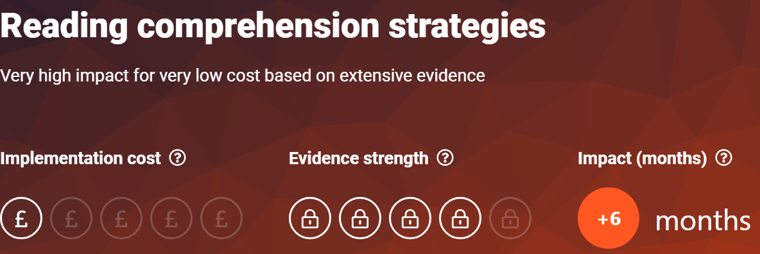  https://educationendowmentfoundation.org.uk/education-evidence/teaching-learning-toolkit/reading-comprehension-strategies | 2

- New assessment cycle implemented for 2024-2025  - Purchase of new assessment materials and diagnostic tools  - Feedback will not be limited exclusively to written marking. Studies of verbal feedback show slightly higher impacts overall (+7 months). Written marking will play one part of an effective feedback strategy, including monitoring impact on staff workload  - Teaching and Learning Coach will provide tailored support for individual teachers | Feedback for Learning  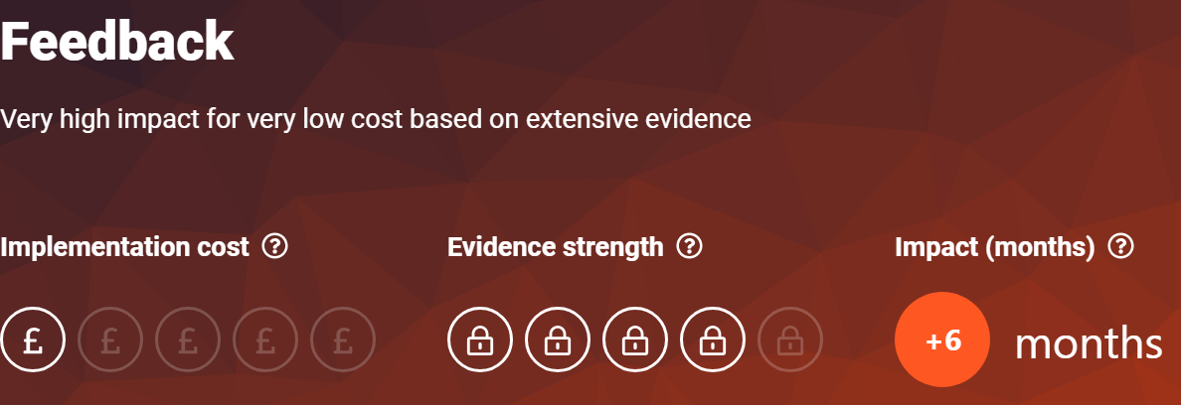  https://educationendowmentfoundation.org.uk/education-evidence/teaching-learning-toolkit/feedback  Teaching and Learning Coaching  https://educationendowmentfoundation.org.uk/education-evidence/guidance-reports/effective-professional-development | 3
- Consistent, whole school approach to quality-first teaching and waves of intervention to create a positive and supportive environment for all pupils, without exception  - Complement high quality teaching with carefully selected small-group and one-to-one interventions  - Learning Support Assistants to be deployed effectively to provide support and improve outcomes for pupils  - Headteacher and Teaching and Learning Lead will engage in the Five Fundamentals of Classroom practice CPD led by HIAS and embed these principles  - Deputy Headteacher will complete the School Wide Advocate for Neurodiversity (SWAN) training led by Hampshire EPs and lead CPD with staff  - The maths lead will engage with the Maths Hub CPD and lead training for staff in Autumn 1, 2025 | Inclusive Practice  https://educationendowmentfoundation.org.uk/education-evidence/guidance-reports/send  EP consultations for staff  Working Memory INSET | 4

Targeted academic support (tutoring, one-to-one support structured interventions)
Budgeted cost: £ 20,295
Activity | Evidence that supports this approach | Challenge number(s) addressed
- Pupil progress meetings after each data drop to identify children who are not making progress towards ARE and address barriers to their learning
- 1:1 reading for pupils whose reading age is below their chronological age  - Precision teaching of key skills in reading, spelling and maths for individual pupils  - Pre-teaching for small groups of children | Precision teaching  https://www.edpsyched.co.uk/blog/precision-teaching-first-steps-guide-and-faq  Pre teaching  https://bedrocklearning.org/literacy-blogs/what-is-preteaching/ | 1, 2, 4
- Same-day teacher led interventions | https://educationendowmentfoundation.org.uk/education-evidence/guidance-reports/feedback | 3

Wider strategies (for example, related to attendance, behaviour, wellbeing)
Budgeted cost: £20,000
Activity | Evidence that supports this approach | Challenge number(s) addressed
- Revisit whole school approach to behaviour and well-being  - PBS and PACE training for all staff | Social and emotional well-being  PACE:  https://www.oxfordshire.gov.uk/sites/default/files/file/children-and-families/PACEforteachers.pdf  PBS Training:  https://pbs.hants.gov.uk/home  Pastoral Lead  In-school TACs and TAFs | 5
- ELSA programmes available for pupils  - Systems for referral and evaluation in place | ELSA:  https://www.elsanetwork.org/elsa-network/ | 5
- Review Attendance Policy in light of new guidelines  - Use of DfE Dashboard for attendance monitoring  - Responsive and targeted approaches to attendance  - Identification of the causes of absences and then responsive, individualised  interventions that tackle those causes | https://educationendowmentfoundation.org.uk/education-evidence/leadership-and-planning/supporting-attendance  DfE Guidance:  https://www.gov.uk/government/publications/working-together-to-improve-school-attendance | 6
- Financial support for pupil entitled to Pupil Premium to attend clubs, trips and extra-curricular activities | Enrichment:  Outdoor Adventure Learning might provide opportunities for disadvantaged pupils to participate in activities that they otherwise might not be able to access. Through participation in these challenging physical and emotional activities, outdoor adventure learning interventions may support pupils to develop non-cognitive skills such as resilience, self-confidence and motivation. | 7
- Morning Nurture Provision and breakfast led by ELSAs
- Engagement with MHST for whole school, class and group sessions and targeted 1:1 intervention
- Development of Forest School provision for vulnerable pupils
- Sensory Circuits and regulation training for staff to support all learners

