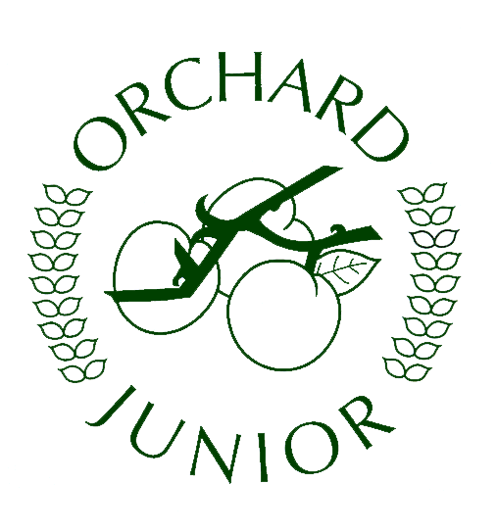
Year 5 Newsletter - Autumn Term 2
The Victorians – Lighting the Way.
Welcome back to a new half term and only about seven weeks until Christmas! The children have really started to settle in and we are delighted with their approach to learning and the amazing work they produced during the recent water topic. This half term promises to be a memorable one as we look at life in Victorian times. This is always a very popular topic and one that the children get deeply involved in comparing their lives with that of a Victorian child before answering our key questions, “Would you rather be a poor or rich child?”.
We have lots of carefully planned activities for the children to take part in at school to help bring this topic to life. Any support you can offer your child, at home, throughout this History topic will be very much appreciated.

Key dates for the future to pop in your diary:
Victorian School Day – Dress up day: Wednesday 30th November 2022. We will be in role for the morning as Victorian teachers as your child experiences what school life was like during the Victorian times. Your children will need to come to school on that day dressed as a Victorian child. Please keep it simple – grey trousers/skirt and a grubby top will do.

Christingle Service at St Andrew’s Church: Wednesday 14th December (arrive at 10:30am for a 10:45am start) – this will be a service for our Year 5 children and parents. The service will be no longer than an hour long. We hope that you will be able to join us as we prepare for Christmas with this special service. The children will make a Christingle at school, that they will bring along with them to the church. Due to St Andrew’s Church being so close, we will walk the children up to the church so please ensure your child has their coat in case the British weather is against us.

**CHANGE OF DATE** - On Thursday 8th December, there will no longer be a Victorian Christmas in the hall due to Year 5 already preparing for the Christingle service. Instead, we would like to use this day as our DT Day where the children will use sewing skills to create bookmarks. Due to the nature of the activity, we would really appreciate as much adult support as possible with this. Please look out for a letter that will follow where you can sign up for a slot to help support your child’s class.

Extended learning opportunity:
We have been so impressed by some of the additional learning on rivers that went on last term. From posters to river models, we have seen children engaged with their topic work at home. Thank you for your support in this. This half term, we are encouraging the children to carry out some research on a famous Victorian of their choice. We would like them to find out interesting details about their Victorian with a focus on why they are famous today. What did they discover/achieve? Why are they considered to be an important Victorian? Here are some suggestions, but the choice is theirs! Again, presentation style is totally up to them! If your child would like to take part in this research, we ask that the work be given in by Friday 10th December.
Famous Victorians – suggestions: Florence Nightingale Charles Darwin Isambard Kingdom Brunel Lewis Carroll
Mary Seacole Joseph Lister Queen Victoria Grace Darling

In Literacy:
In Literacy, we will begin the half term by immersing ourselves in our class text, Street Child. The children will investigate what the text tells us about the key characters as well as gathering evidence about life in the Victorian era. Using the themes from the text, the children will write poetry, based upon the emotions that the key characters feel at different points of the story. They will also be looking at the dilemmas that the main character, Jim Jarvis, faces during this book. This will lead to the children writing balanced arguments, offering their own opinion at the end.

In Maths:
In maths, we will continue to work on the four operations of number with a particular focus on methods for multiplication and division as this was an area that all the children struggled with based on our recent assessments. The children will move onto multiplying by 2-digit numbers where they will use the short multiplication method before trying to apply this knowledge to a range of worded problems. After, we will move onto division and the children will, again, learn the short method for dividing but will only divide by 1-digit numbers (Year 6 will look at dividing by 2-digit numbers).

In Science:
This half term, we will be considering how light travels and reflects. The children will be involved in investigating how the properties of light are used in periscopes. They will consider how scientists show the passage of light on scientific diagrams, leading to them planning and then building their own periscopes. This is always a lot of fun and the children enjoy looking at how periscopes have been used throughout history.

In History:
This topic is one of our main history topics this year. To begin with, the children will look at pictures and artefacts to infer what life was like during the Victorians as well as seeing if artefacts are similar to items we have today. The main focus of the History unit is to investigate the life of rich and poor children during the Victorian era by comparing different aspects of their lives such as jobs, homes and education. After researching this information, the children will decide whether they would have preferred to be a rich or a poor child during this period of time.

Other subjects:
In ICT the children will be carrying out research and designing a Victorian classroom to develop their skills on Publisher.
In Design and Technology, we will be looking at how sewing was used to make toys and precious items in the 1800s. The children will design and make their own Victorian cross-stitched bookmark…..wish us luck!
In PSHE, we will be continuing our unit on relationships such as friends, families and feeling safe.

Homework:
Homework will continue to be on the same days as last half-term.
Monday – Reading records in with a minimum of 3 reads which need to be signed by an adult. Please try to read with your child and ask questions about what they are reading to help improve their understanding of the text rather than just reading the words.
Wednesday – Times tables. The children will be tested and then given practise sheets to be handed in the following week.
Friday – Spellings. The children need to complete their Look, Cover, Write, Check, Edit sheet each week, which will already have their spellings on. The children will also be tested each Friday before being given their new spellings. Please look carefully at the rules as this will help support them with spelling other words with the same rule – we also look at the rule in class too.

Many thanks for your ongoing support. Remember, if you have any queries or concerns, you are welcome to email us
using the class email address.
The Year 5 Team – Mrs Morgan, Mr Battersby and Miss Kerr

