Orchard Junior School

Progression in calculation

[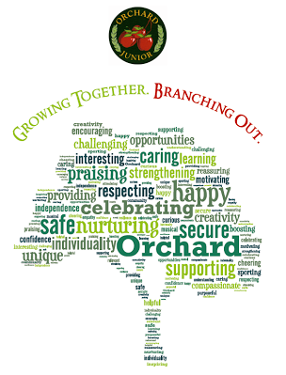](http://www.google.co.uk/url?sa=i&rct=j&q=&esrc=s&frm=1&source=images&cd=&cad=rja&uact=8&ved=0CAcQjRw&url=http://www.orchardjunior.com/&ei=RoXrVJzBNsiuU5yQhLAM&bvm=bv.86475890,d.d2s&psig=AFQjCNHYly7b3071T3G9qZs4P_zQE0v95g&ust=1424807613825320)

Whole school policy for the progression of addition throughout the school

* Children should work through the following progression in line with National Curriculum expectations if appropriate.
* Appropriate and consistent vocabulary will be used throughout the school.
* Practical resources will support the learning of addition throughout the school moving on to drawings and representations when secure.
* Mental addition strategies will be taught throughout the school to encourage fluency with number bonds, and counting on in different steps
* Informal and then formal written methods will be used throughout the school for increasingly large numbers
* Children should be able to work out when addition is needed to solve a problem and then whether a mental or written strategy is most effective
* Children should understand and use the relationship between addition and subtraction
* Children will also learn strategies to estimate and to check their answer is reasonable.

|  |
| --- |
| Addition using objects and pictures |

Children will begin by counting the objects in one group and the objects in another. They will then put them together and count the total number.

Next steps…

Children will start with a group of objects of a known number and count on another group of objects to find the total.

*Example problem – Farmer Jones picks 7 apples. He picks 3 more. How many does he have altogether?*

 



7 count on 3 more makes 10.

Number sentence 7 + 3 =10 (7 apples and 3 more apples)

Inverse 10 – 3 = 7 (10 apples take away 3 apples)

Children should count on from the largest number.

This can then be extended by children drawing pictures rather than using objects.

|  |
| --- |
| Addition on a structured number line |

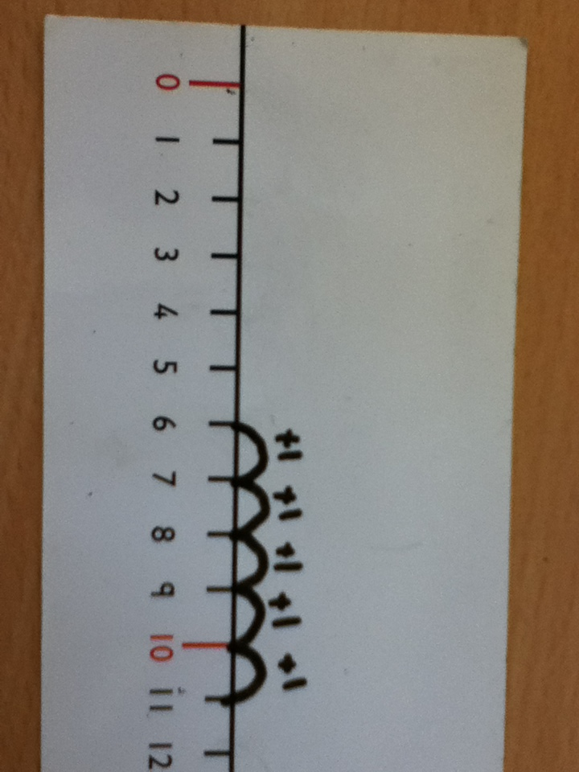

Children can start by putting the objects on the number line that they are familiar with and then progress to using the number line without the objects.

Children can then start by marking the largest number on the number line and counting on.

*Example problem – I have 5 sweets and I buy 6 more. How many do I have now?*

Number sentence 6 + 5 = 11 (6 sweets and then add 5 more)

Inverse 11 – 5 = 6 (11 sweets subtract 5)

Children should be able to count back on the number lines to check the answer is correct and also to understand about inverse.

|  |
| --- |
| Addition in tens and ones on a structured number line |

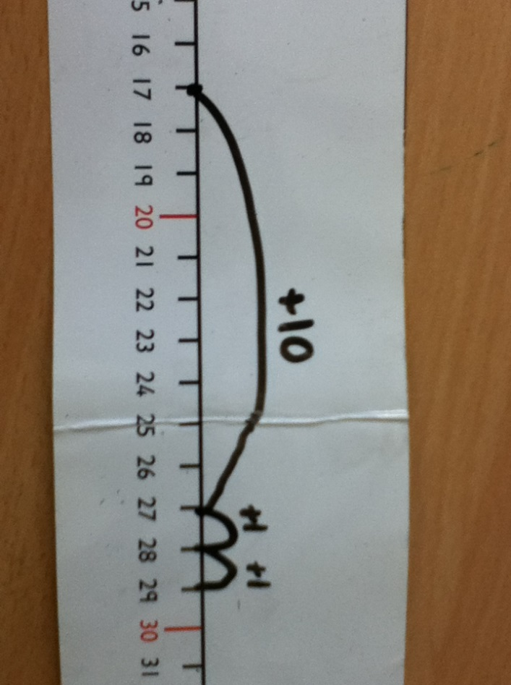Children can then move onto jumps of 10’s and 1’s on a structured number line. The children should be able to make jumps of 10 following known patterns

*Example problem – I have 17 conkers and I collect 12 more. How many do I have altogether?*

Number sentence 17 + 12 = 29 (17 conkers then add 12 more)

Inverse 29 – 12 = 17 (29 conkers subtract 12)

|  |
| --- |
| Addition in ones on an unstructured number line |

Children draw their own number line. On the number line they record the number they are starting from (the highest) and the number they land on after each jump.

*Example problem – The school has 12 footballs. Miss Smith buys 5 more. How many does the school have now?*

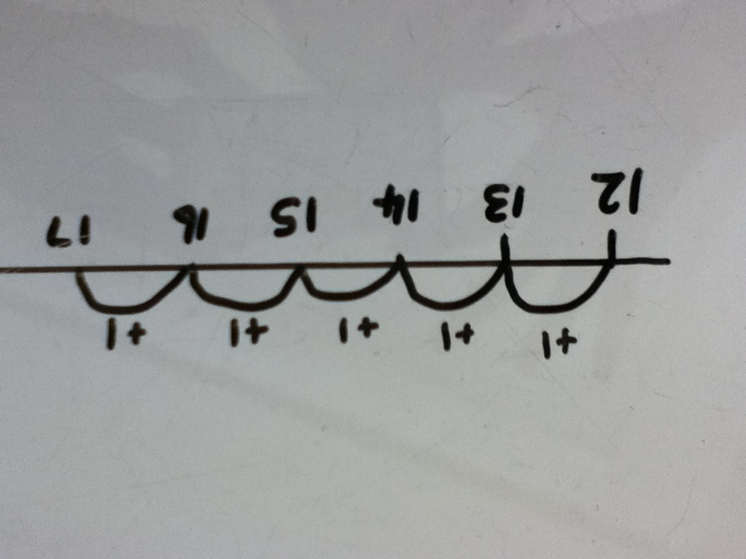

Number sentence 12 + 5 = 17 (12 footballs and then add 5 more)

Inverse 17 – 5 = 12 (17 subtract 5)

|  |
| --- |
| Addition in tens and ones on an unstructured number line |

As before, children draw their own number line and record the starting point. They partition the number they are adding into tens and ones. They then add on the ten and then the ones.

*Example problem – There were 17 butterflies in the garden. Then another 14 joined them.*

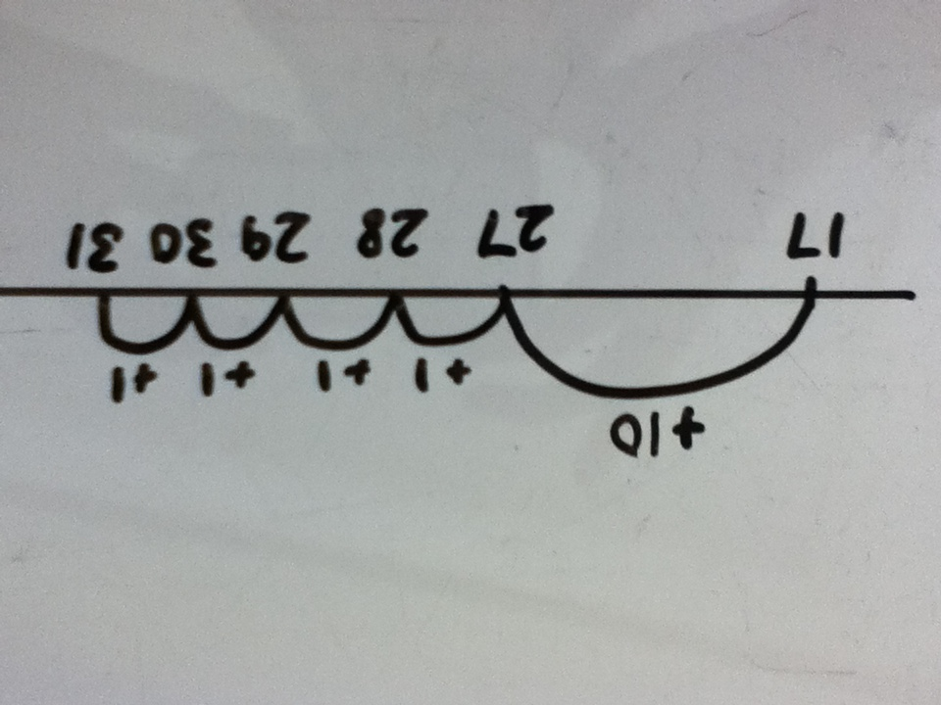

Number sentence 17 + 14 = 31 (17 butterflies then add 14 more)

Inverse 31 – 14 = 17 (31 subtract 14)

The children may start using jottings to support their work.

The next stage is to move the children on to adding on numbers with more than one ten. (E.g. 64 + 43)

PLEASE NOTE – children need to be able to count on in tens before they use this method. (Using resources such as Numicon or arrow cards)

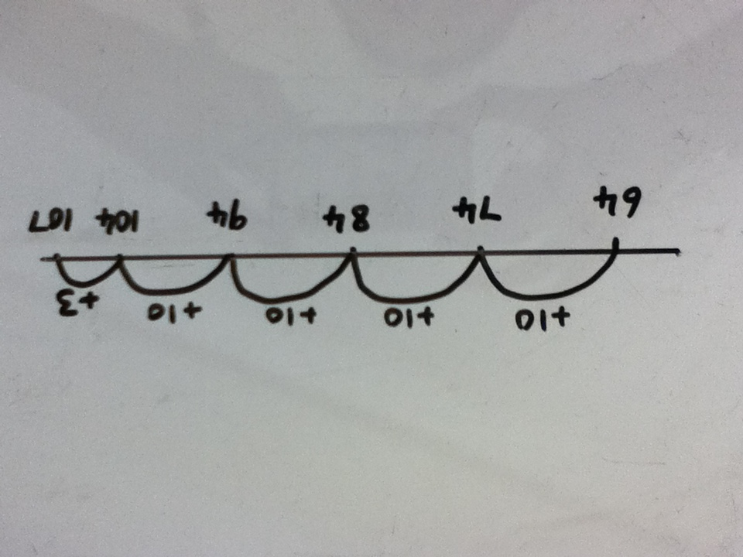

Children should then start combining their jumps so that they can jump on 40 rather than 4 lots of 10.

*Example problem – Sara had 54 marbles and then bought 32 more from the shop. How many does she have in total?*

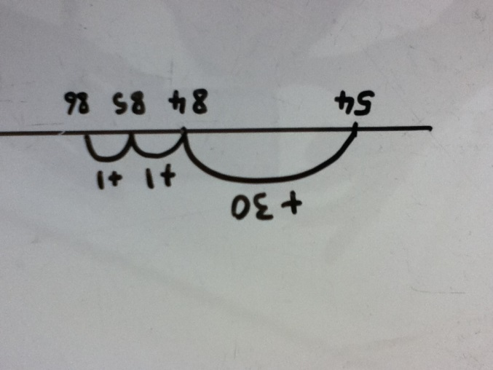

Number sentence 54 + 32 = 86 (54 marbles and then add 32)

Inverse 86 – 32 = 54 (86 subtract 32)

|  |
| --- |
| Addition on an unstructured number using number bonds |

The next stage is to partition the units by bridging the nearest 10.

*Example problem – Matt had 54 marbles and then bought 37 more from the shop. How many does he have in total?*

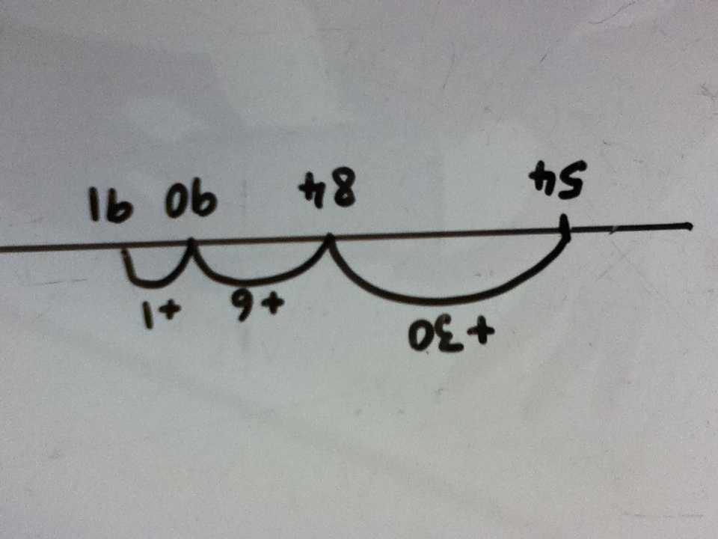

Number sentence 54 + 37 = 91 (54 marbles and then add 37)

Inverse 91 – 37 = 54 (91 subtract 37)

Children start from the largest number, then add on the tens. They then partition the units to bridge to the nearest 10. Finally they add on the remaining units.

|  |
| --- |
| Addition using partitioning without the number line. |

Once children are confident using an unstructured number line and counting on in multiples of 10 and partitioning the units THEN they can move on. Children so not need to be adding thousands on a number line – they need to be moved on to more efficient methods. However, they will need to have the number line alongside whilst learning a new method to understand the links.

*Example problem - I had 423 nails to make a fence. I bought 132 more. How many nails do I have altogether?*

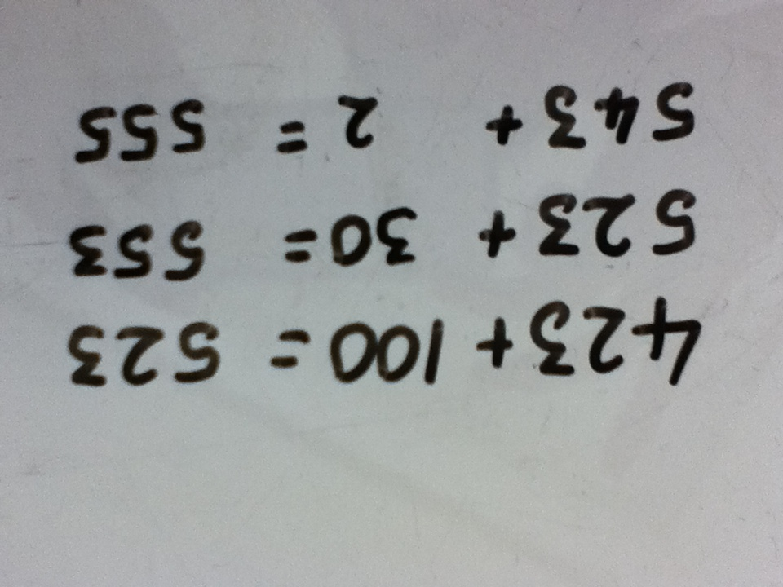

Number sentence 423 + 132 = 555 (423 add 132)

Inverse 555 – 132 = 423 (555 subtract 132)

Children’s jottings need to make sense. This, for example, is not mathematically correct.

423 + 100 = 523 + 30 = 553 + 2 = 555.

|  |
| --- |
| Addition using expanded method moving onto carrying |

Once children are confident and understand the value of the digits and the partitioning then they can move on to the vertical expanded method. Again, teach alongside their existing method to ensure understanding.

There are two ways of using the expanded method. All children should start on the first method. The children who are confident with partitioning can then move on through the second method towards carrying. However, children who are struggling more with place value should keep following the first method through towards carrying.

*Example problem – Clare had £145. She won £121 on the lottery. How much does she have now?*

Method 1

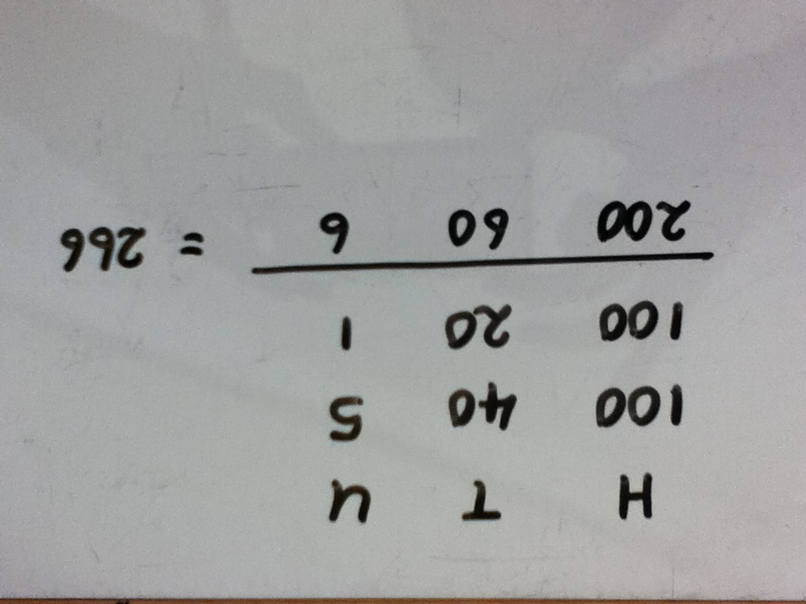

Number sentence 145 + 121 = 266 (£145 add £121)

Inverse 266 – 121 = 145 (£266 subtract 121)

Progression towards carrying.

*Example problem - Paul had £157 and his brother had £135. How much do they have altogether?*

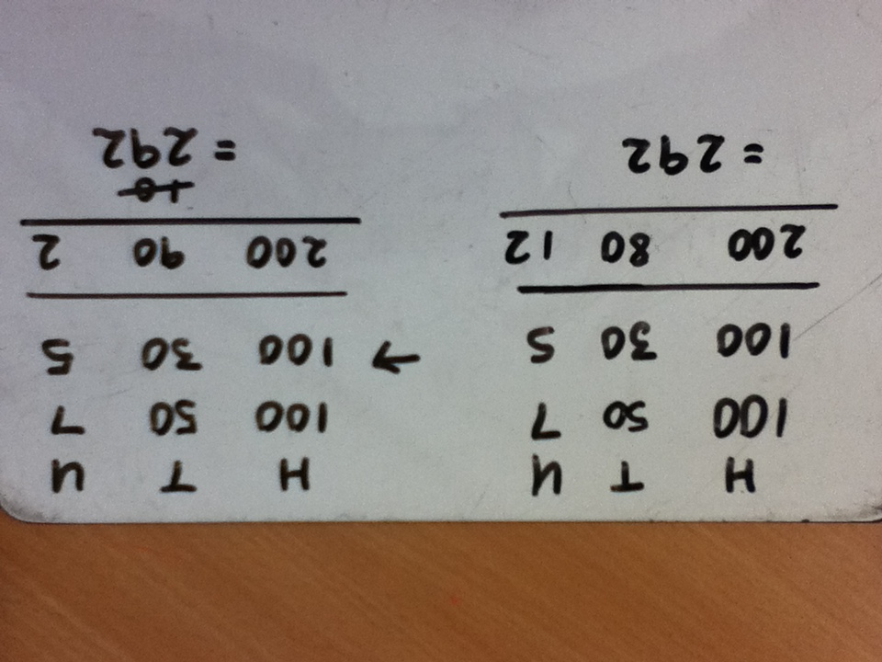

Method 2

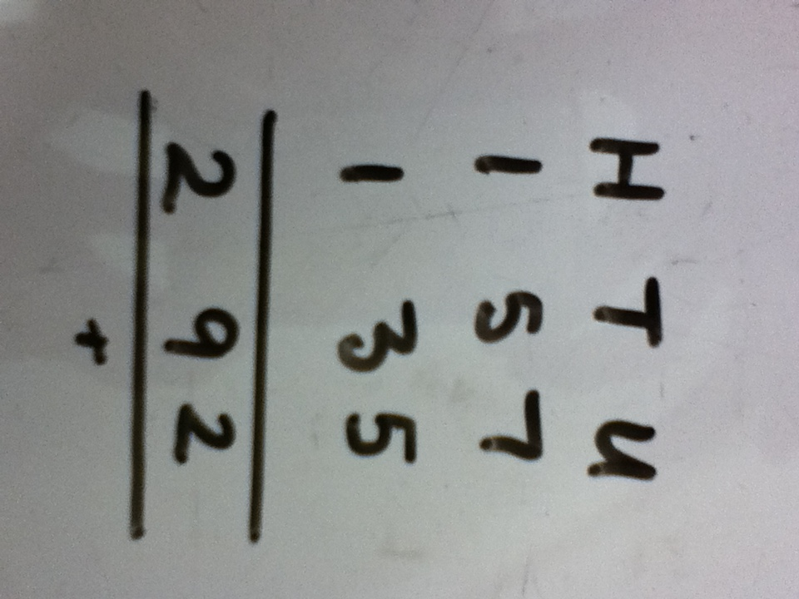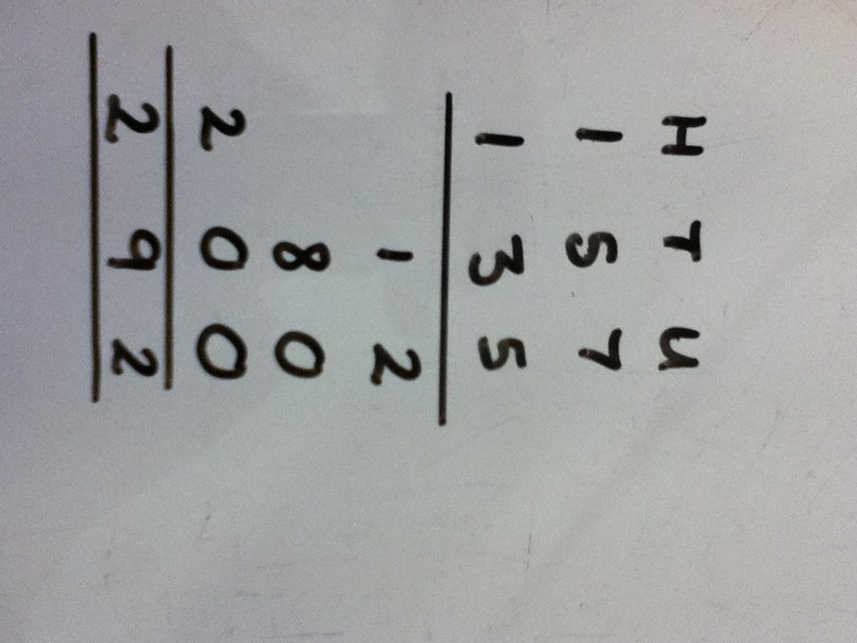

*In this method children are using HTU at the top of the columns to remind them of the value of the digits. If using this method then the child should be able to tell you that the 9 in the answer is 90 made from adding 80 + 10 OR that is 9 tens which is the total of 8 tens and 1 ten.*

|  |
| --- |
| Addition using the short method. |

*Example problem – Sam walked from home to the shop which was 345m. He then walked 256m to his friend’s house. How far had he walked altogether?*

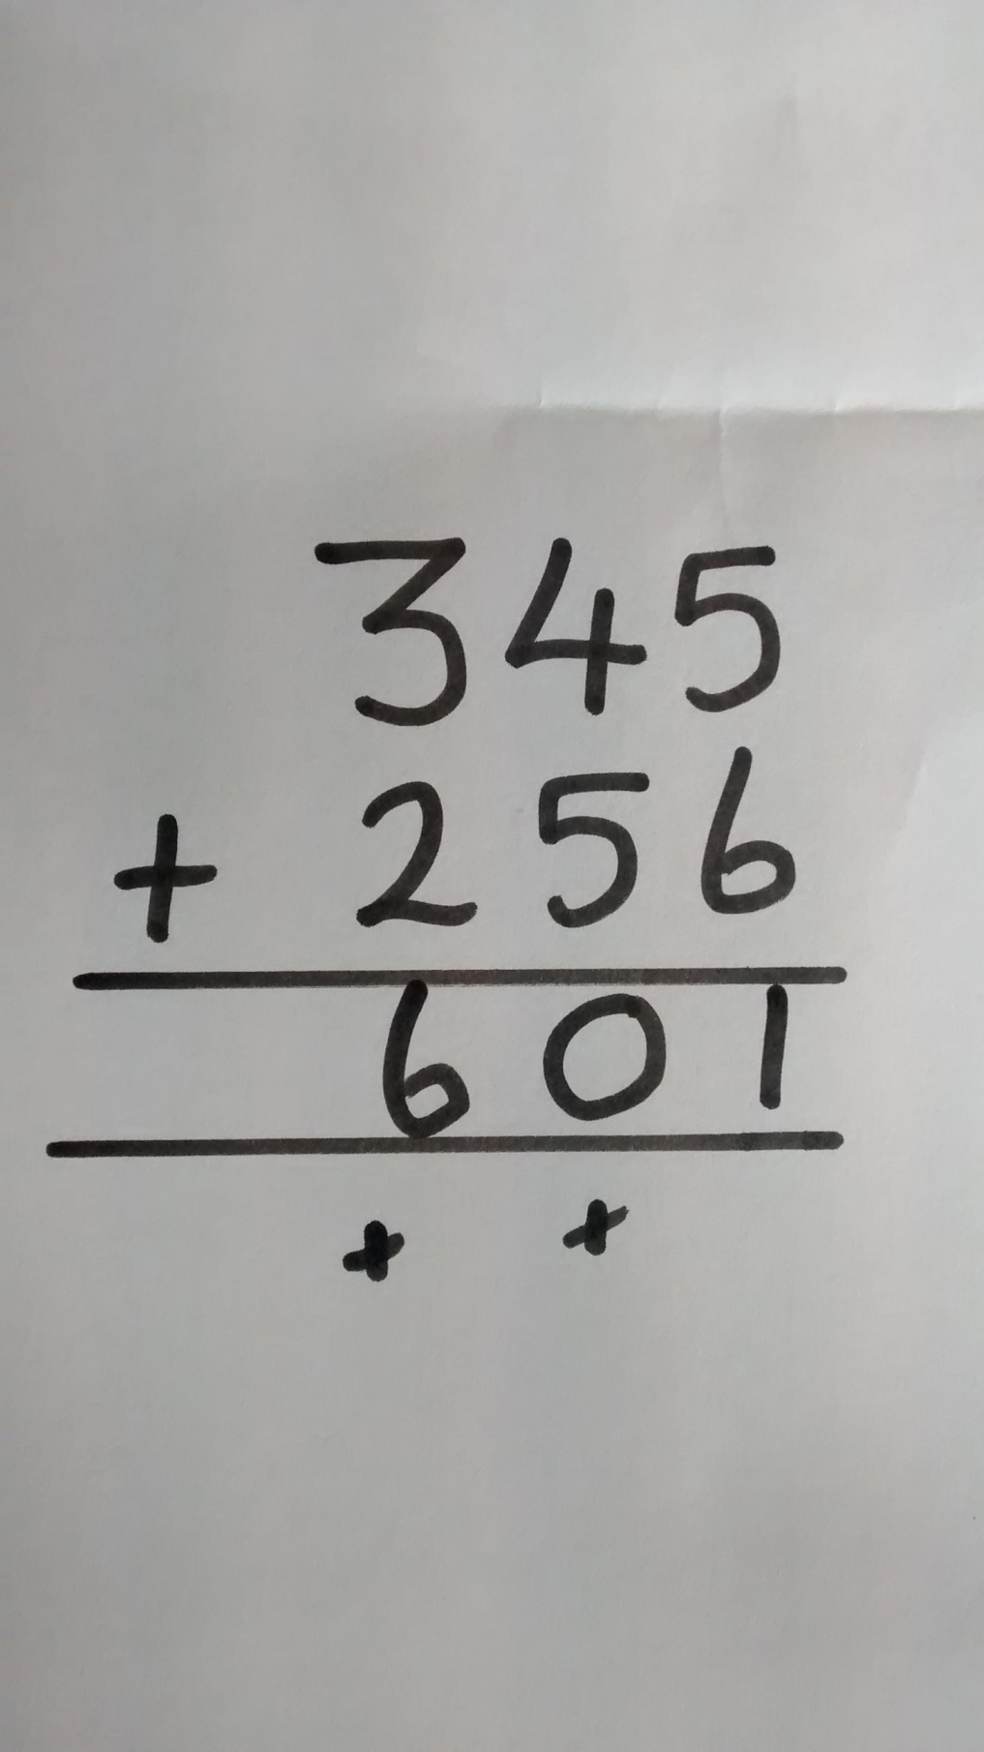

Number sentence 345 + 256 = 601 (345m add 601m)

Inverse 601 – 256 = 345 (601m – 256m)

Once children are confident they can move onto addition with decimals but first they need to show you that they understand the value of the tenths and the hundredths column. For example, when working with money they should know that 10 tenths = 1 whole (ten 10p’s = £1)

Whole school policy for the progression of subtraction throughout the school

* Children should work through the following progression in line with National Curriculum expectations if appropriate.
* Appropriate and consistent vocabulary will be used throughout the school.
* Practical resources will support the learning of subtraction throughout the school moving on to drawings and representations when secure.
* Mental subtraction strategies will be taught throughout the school to encourage fluency with number bonds, and counting back in different steps
* Informal and then formal written methods will be used throughout the school for increasingly large numbers
* Children should be able to work out when subtraction is needed to solve a problem and then whether a mental or written strategy is most effective
* Children should understand and use the relationship between subtraction and addition
* Children will also learn strategies to estimate and to check their answer is reasonable.

|  |
| --- |
| Subtraction using objects and pictures |

Children will begin by taking away a given number one at a time and finding out how many are left. Use practical resources such as apples or cubes.

*Example problem – I have 7 apples, I eat 3. How many do I have left?*



Number sentence 7 – 3 = 4 (7 sweets take away 3 sweets)

Inverse 4 + 3 = 7 (4 sweets add 3 sweets)

This can then be extended by children drawing pictures rather than using objects. They can cross out the objects that are being taken away.

*Example problem – I have 14 sweets and give away 5. How many do I have left?*

j0291062[2]

j0291062[2]

j0291062[2]

j0291062[2]

j0291062[2]

j0291062[2]

j0291062[2]

j0291062[2]

j0291062[2]

j0291062[2]

j0291062[2]

j0291062[2]

j0291062[2]

j0291062[2]

Number sentence 14 – 5 = 9 (14 sweets take away 5 sweets)

Inverse 9 + 5 = 14 (9 sweets add 5 sweets)

|  |
| --- |
| Subtraction on a structured number line |

Children place objects on a structurednumber line and count back in ones as they take away. Next, they draw the objects on a structured number line and count back in ones as they take away.

*Example problem - I have 13 apples. I give 8 to a friend. How many apples have I got now?*

Objects taken away, or if drawn crossed out.

|  |  |  |  |  |  |  |  |  |  |  |  |  |  |  |  |  |  |  |  |  |  |  |  |  |  |  |  |
| --- | --- | --- | --- | --- | --- | --- | --- | --- | --- | --- | --- | --- | --- | --- | --- | --- | --- | --- | --- | --- | --- | --- | --- | --- | --- | --- | --- |
|  | | MCj04348230000[1] | | MCj04348230000[1] | | MCj04348230000[1] | | MCj04348230000[1] | | MCj04348230000[1] | | MCj04348230000[1] | | MCj04348230000[1] | | MCj04348230000[1] | | MCj04348230000[1] | | MCj04348230000[1] | | MCj04348230000[1] | | MCj04348230000[1] | | MCj04348230000[1] | |
|  |  | |  | |  | |  | |  | |  | |  | |  | |  | |  | |  | |  | |  | |  |
| 0 | | 1 | | 2 | | 3 | | 4 | | 5 | | 6 | | 7 | | 8 | | 9 | | 10 | | 11 | | 12 | | 13 | |

Number sentence 13 – 8 = 5 (13 apples take away 8 apples)

Inverse 5 + 8 = 13 (5 apples add 8 apples)

Next children count back in ones on a structurednumber line without objects or pictures to help them.

*Example problem – I have 12 carrots and my donkey eats 5. How many do I have left?*

|  |  |  |  |  |  |  |  |  |  |  |  |  |  |  |  |  |  |  |  |  |  |  |  |  |  |  |  |
| --- | --- | --- | --- | --- | --- | --- | --- | --- | --- | --- | --- | --- | --- | --- | --- | --- | --- | --- | --- | --- | --- | --- | --- | --- | --- | --- | --- |
|  |  | |  | |  | |  | |  | |  | |  | |  | |  | |  | |  | |  | |  | |  |
| 0 | | 1 | | 2 | | 3 | | 4 | | 5 | | 6 | | 7 | | 8 | | 9 | | 10 | | 11 | | 12 | | 13 | |

Number sentence 12 – 5 = 7 (12 carrots take away 5 carrots)

Inverse 7 + 5 = 12 (7 carrots add 5 carrots)

|  |
| --- |
| Subtraction on an unstructured number line |

Children draw their own number line and start by counting back in ones. Then move on to counting back in tens and ones. Children need to understand partitioning to be able to do this. They should move towards being able to count back the units in one jump rather than in 1’s.

*Example problem – There were 36 birds in a bush, but 17 flew away.*

*How many are left in the bush?*

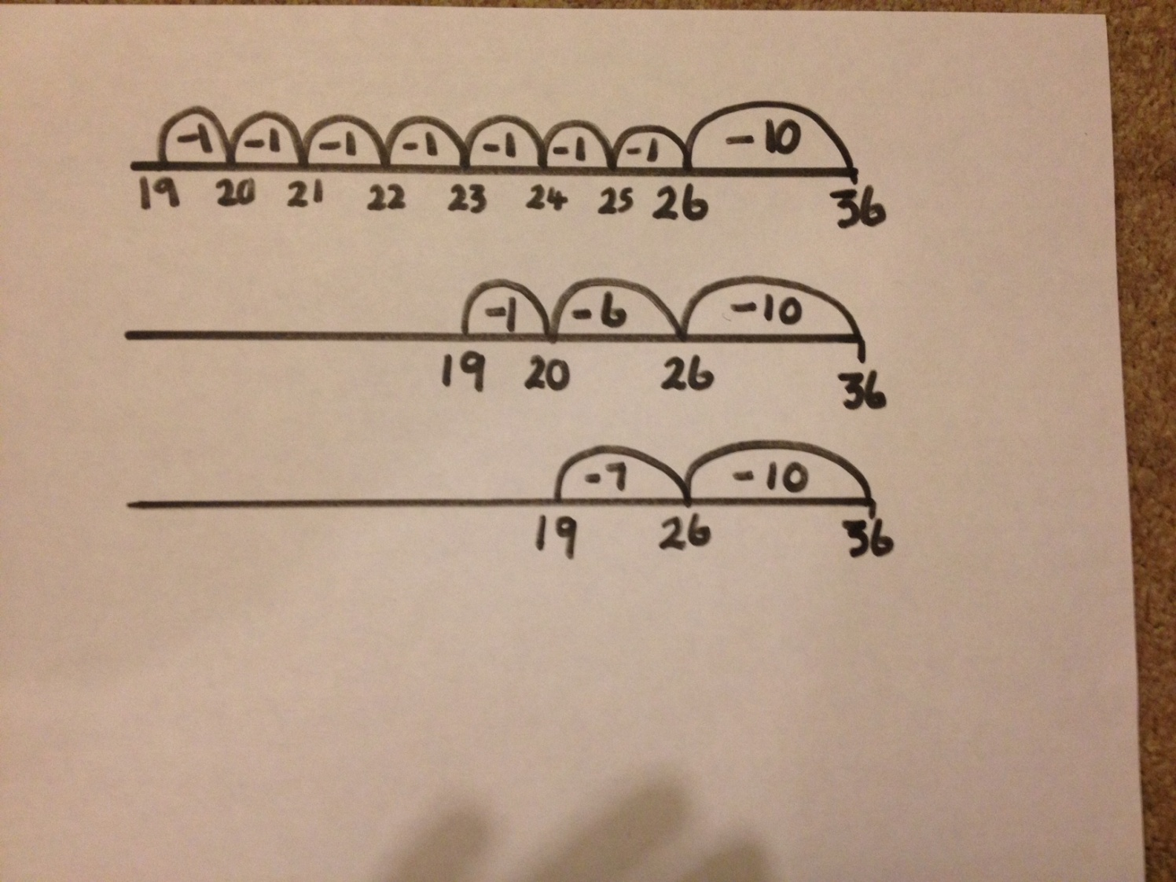

Number sentence 36 – 17 = 19 (36 birds take away 17 birds)

Inverse 19 + 17 = 36 (19 birds add 17 more birds)

Children then move on to counting back in multiples of 10

*Example problem – I have 85 Football cards and I lose 46 of them. How many Football cards do I now have?*

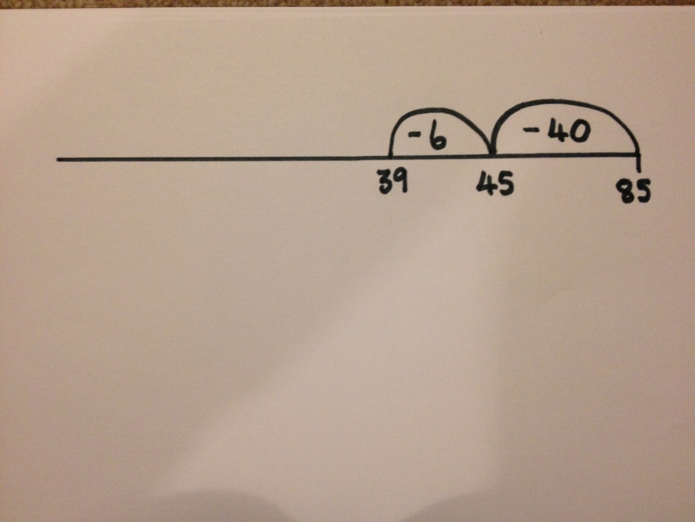

Number sentence 85 – 46 = 39 (85 cards subtract 46)

Inverse 39 + 46 = 85 (39 cards add 46 cards)

This method can then be extended to HTU – TU and HTU - HTU

|  |
| --- |
| Jottings |

Alongside this children can use jottings which will then extend into more formal written methods.

*For example:*

85 – 40 = 45

45 – 6 = 39

|  |
| --- |
| Subtraction with partitioning |

Children should present the calculation vertically with the numbers partitioned under HTU headings. Children should subtract the units first, then the tens and then the units.

*Example problem – I had £79 and bought a new coat for £25. How much money did have left?*

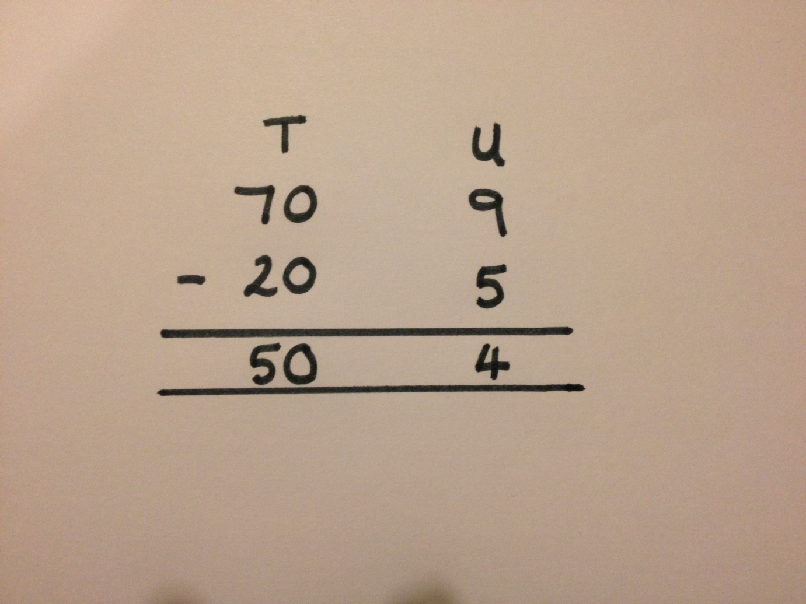

Number sentence 79 – 25 = 54 (£79 subtract £25)

Inverse 54 + 25 = 79 (£79 add £25)

|  |
| --- |
| Decomposition with partitioning |

When using this method children need to start by looking at the units and ask themselves the questions, “Can I do it? Is there enough?” If there is not enough then they need to exchange one of the tens for ten units.

*Example problem - I had £74 and I spend £27 on a new pair of shoes. How much money do I have left?*

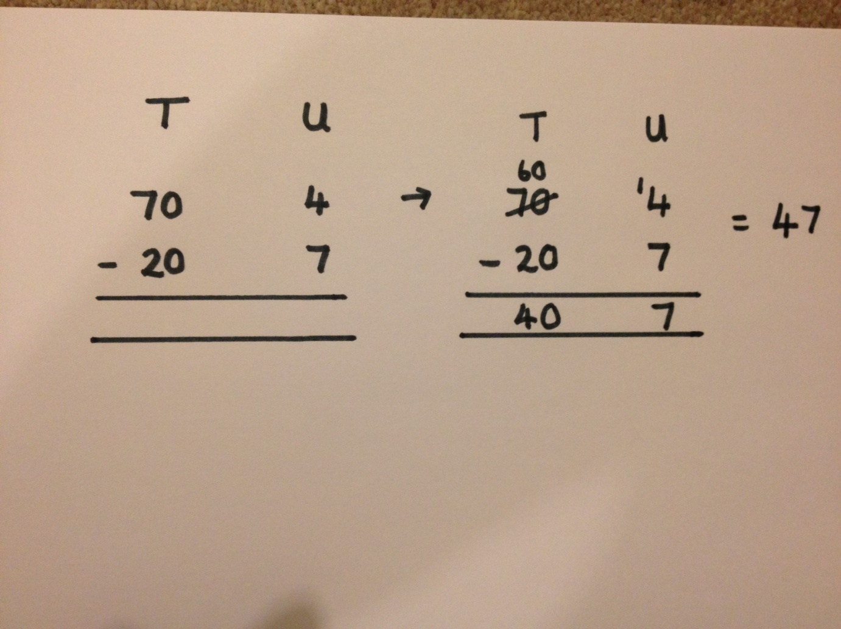

Number sentence 74 – 27 = 47 (£74 subtract £27)

Inverse 47 + 27 = 74 (£47 add £27)

This method can be extended for HTU – HTU

*Example problem - I had £741 and I spend £367 on a new pair of shoes. How much money do I have left?*

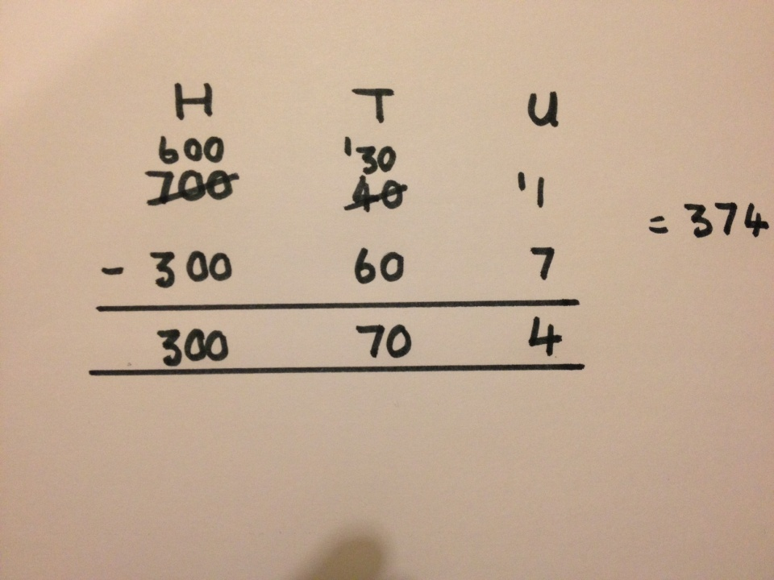

Number sentence 741 – 367 = 374 (£741 subtract £367)

Inverse 374 + 367 = 741 (£374 add £367)

Children should be specifically taught what to do when there are zeros in the tens column in HTU – HTU. Children should not exchange 1 hundred for 10 units. Explain by referring to place value.

E.g. 503 – 278 =

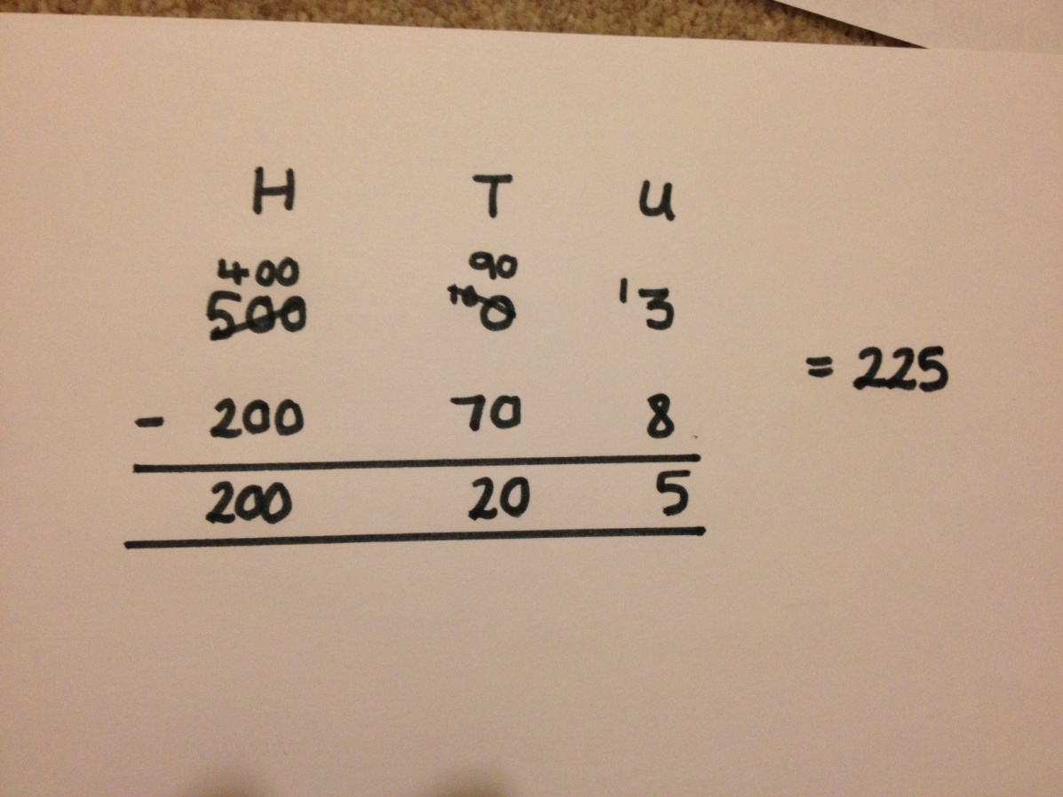

|  |
| --- |
| Short method |

Once children are confident using partitioning for subtraction they can move on to the short method. This involves exchanging without partitioning the numbers first. Children should be able to explain the place value of the numbers and why they can be exchanged.

*Example problem – A piece of wood is 541 cm long. How long is it after 376cm is chopped off?*

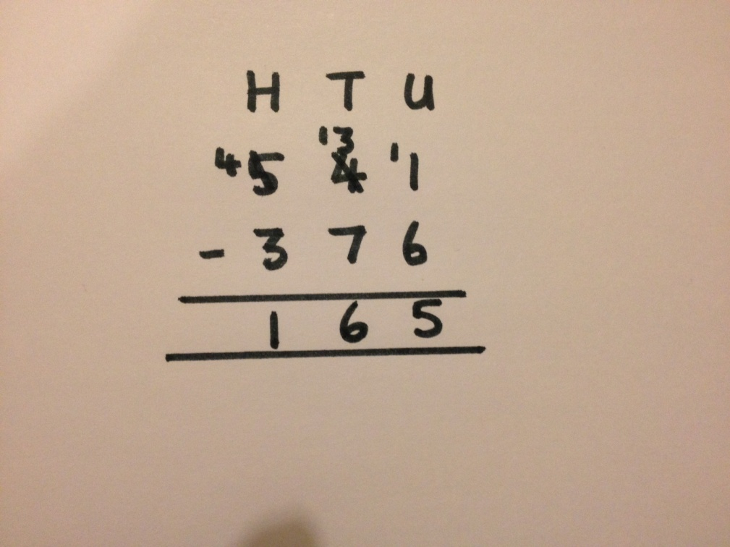

Number sentence 541 – 376 = 165 (£541 subtract £376)Inverse 165 + 376 = 541 (£165 add £376)

Whole school policy for the progression of multiplication throughout the school

Our policy:

* Children should work through the following progression in line with National Curriculum expectations if appropriate.
* Appropriate and consistent vocabulary will be used throughout the school.
* Practical resources will support the learning of multiplication throughout the school moving on to drawings and representations when secure.
* Mental multiplication strategies will be taught throughout the school to encourage fluency with times tables and application of these facts.
* Informal and then formal written methods will be used throughout the school for increasingly large numbers
* Children should be able to work out when multiplication is needed to solve a problem and then whether a mental or written strategy is most effective
* Children should understand and use the relationship between multiplication and division through representations such as arrays.
* Children will also learn strategies to estimate and to check their answer is reasonable

|  |
| --- |
| Multiplication using objects and pictures |

Children will arrange objects or pictures into groups. Then add the groups together using repeated addition.

*Example problem - I have 3 boxes. There are 2 eggs in each box. How many eggs do I have?*







2 + 2 + 2 = 6

Number sentence 3 x 2 = 6 (3 boxes of 2 eggs)

Inverse 6 ÷ 2 = 3 (6 eggs can be put into 3 boxes of 2)

This can then be extended by children drawing pictures rather than using

objects.

|  |
| --- |
| Multiplication as repeated addition on a structured number line |

Children can start by putting objects on the number line in groups. This can move on to counting in groups (using repeated addition.) Children record how many is added on in each jump.

*Example problem – Apples are put in bags of 5. If I have 4 bags then how many apples do I have altogether?*

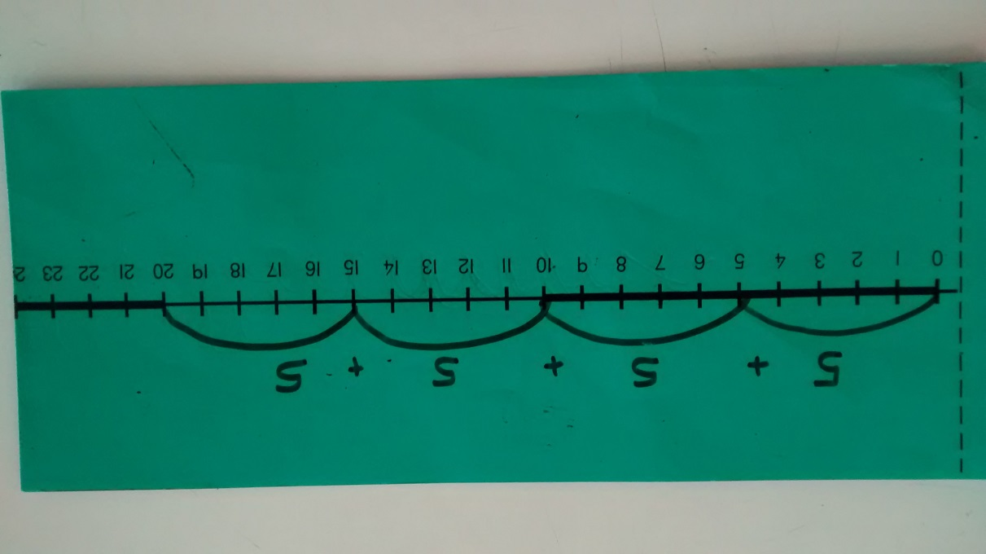

*Number sentence 5 x 4 = 20* (4 bags of 5 apples)

Inverse 20 ÷ 5 = 4 (20 apples can be put into 4 bags of 5)

|  |
| --- |
| Multiplication as repeated addition on an unstructured number line |

Children draw out their own number line. On the number line the record where they start and the number they land on after each jump. They also record how many is added on in each jump.

*Example problem – Cakes are put in boxes of 4. If I have 6 boxes then how many cakes do I have altogether?*

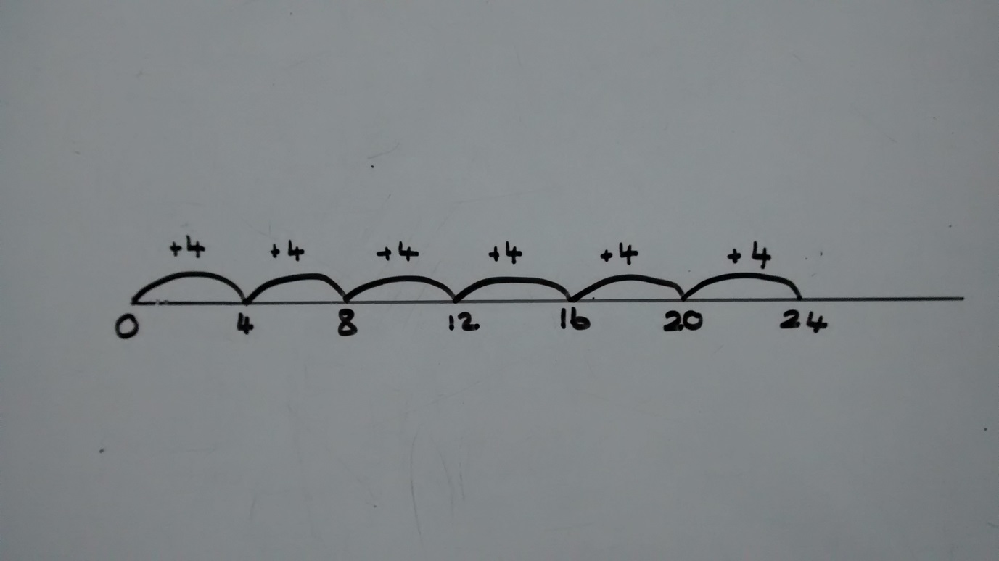

*Number sentence 4 x 6 = 24* (6 boxes of 4 cakes)

Inverse 24 ÷ 4 = 6 (24 apples can be put into 6 boxes of 4)

|  |
| --- |
| Using arrays alongside number lines |

Arrays should be used alongside number lines to reinforce repeated addition and also to consolidate understanding of inverse.

*Example problem - There are 5 chairs in three rows. How many chairs are there?*

5 chairs in each row

|  |  |  |  |  |
| --- | --- | --- | --- | --- |
| MCj04134580000[1] | MCj04134580000[1] | MCj04134580000[1] | MCj04134580000[1] | MCj04134580000[1] |
| MCj04134580000[1] | MCj04134580000[1] | MCj04134580000[1] | MCj04134580000[1] | MCj04134580000[1] |
| MCj04134580000[1] | MCj04134580000[1] | MCj04134580000[1] | MCj04134580000[1] | MCj04134580000[1] |

3 rows of chairs

Number sentence 5 x 3 = 15 (3 rows of 5 chairs)

*or 3 x 5 = 15 (5 rows of 3 chairs)

Inverse 15 ÷ 5 = 3 (15 chairs can be arranged in 3 rows of 5)

*or 15 ÷ 3 = 5 (15 chairs can be arranged in 5 rows of 3)

When using arrays children can also see the commutative law of multiplication.

|  |
| --- |
| Multiplication using partitioning |

Children will use jottings to partition numbers before multiplying. Children will need a secure understanding of multiplying by 10 and 100.

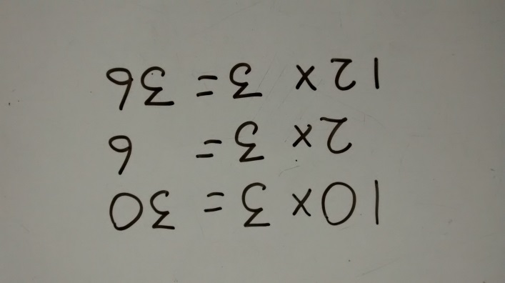*Example problem – There are 12 people on each team. How many are there in 3 teams?*

Number sentence 12 x 3 = 36 (3 teams of 12)

Inverse 36 ÷ 12 = 3 (36 children split into 3 teams of 12))

Arrays and number lines can continue to be used to support work on multiplication using partitioning.

12 x 3 is pictorially broken down into 10 x 3 and 2 x 3

|  |  |  |  |  |  |  |  |  |  |  |  |  |
| --- | --- | --- | --- | --- | --- | --- | --- | --- | --- | --- | --- | --- |
| X |  |  |  |  | 10 | |  |  |  |  | 2 | |
|  | MMj01855860000[1] | MMj01855860000[1] | MMj01855860000[1] | MMj01855860000[1] | MMj01855860000[1] | MMj01855860000[1] | MMj01855860000[1] | MMj01855860000[1] | MMj01855860000[1] | MMj01855860000[1] | MMj01855860000[1] | MMj01855860000[1] |
| 3 | MMj01855860000[1] | MMj01855860000[1] | MMj01855860000[1] | MMj01855860000[1] | MMj01855860000[1] | MMj01855860000[1] | MMj01855860000[1] | MMj01855860000[1] | MMj01855860000[1] | MMj01855860000[1] | MMj01855860000[1] | MMj01855860000[1] |
| MMj01855860000[1] | MMj01855860000[1] | MMj01855860000[1] | MMj01855860000[1] | MMj01855860000[1] | MMj01855860000[1] | MMj01855860000[1] | MMj01855860000[1] | MMj01855860000[1] | MMj01855860000[1] | MMj01855860000[1] | MMj01855860000[1] |
| 10 x 3 = | | | | | | | | | | 2 x 3 = | |

Alongside the array this calculation can be shown on a number line.

|  |
| --- |
| Multiplication using the grid method |

The next step is to use the gird method which is an array without the pictorial representation. Children need to partition the numbers into H T U etc.

*Example problem - There are 17 bunches of flowers in the shop. Each bunch has 8 flowers in it. How many flowers is this altogether?*

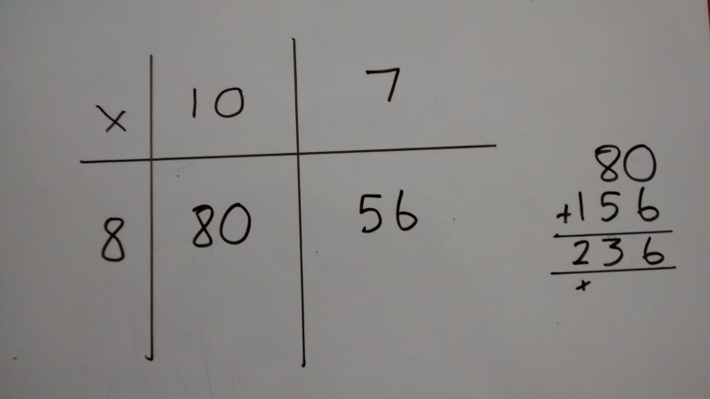

Number sentence 17 X 8 = 136 (17 bunches of 8 flowers)

Inverse 236 ÷ 8 = 17 (236 flowers split into 17 bunches of 8)

This method should be demonstrated alongside partitioning by jottings, number lines or arrays.

TU x TU grids can then be introduced

*Example problem - There are 12 children in a team. How many in 14 teams?*

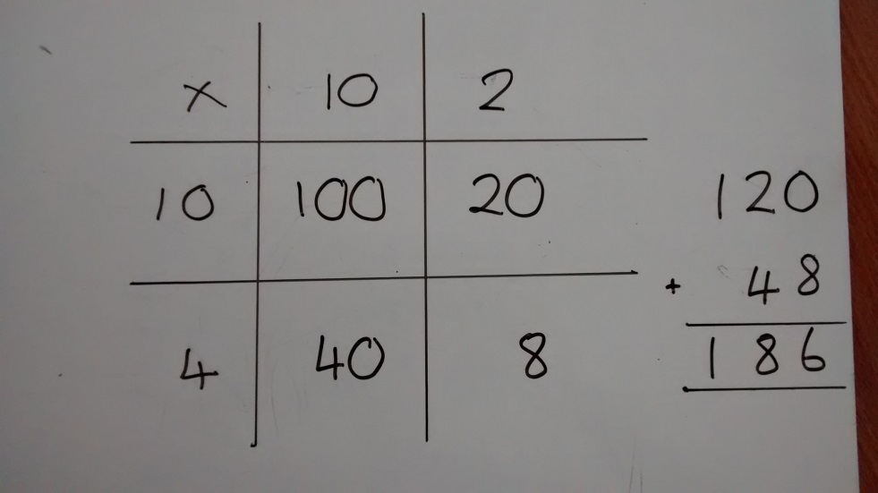

Number sentence 12 x 14 = 168 (14 teams of 12)

Inverse 168 ÷ 12 = 17 (168 children make 17 teams of 12)

Move on to HTU x TU, HTU x HTU and then decimals.

|  |
| --- |
| Multiplication using expanded column method |

The understanding of partitioning, gained from the grid method, can now applied into a vertical expanded method. Children should start by multiplying U x U, then T x U and finally H x U recording their answers underneath. Finally these answers should be added.

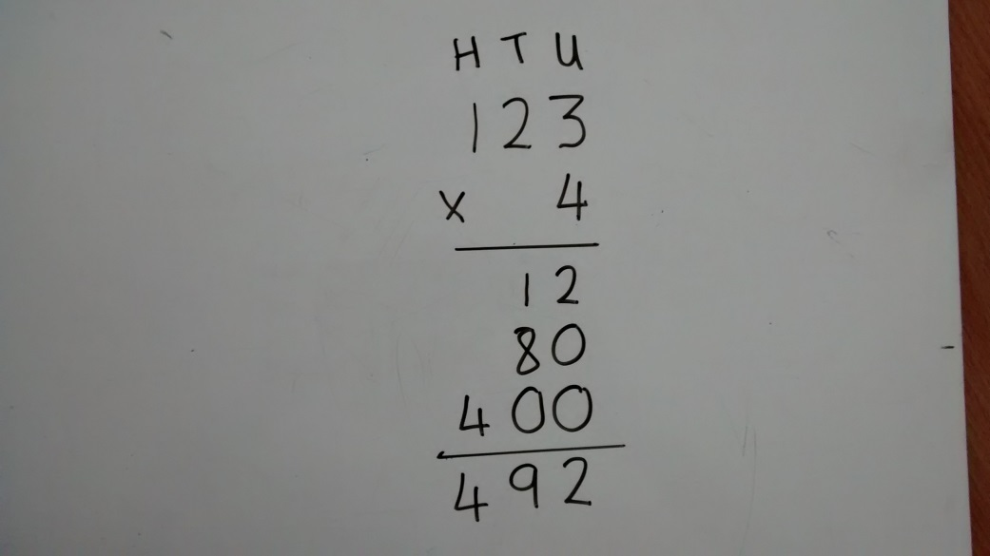

*Example problem – There are 123 pieces of paper in a pack. How many pieces in 4 packs?*

Number sentence 123 x 4 = (123 packs of 4)

Inverse 492 ÷ 4 =123 (492 sheets make 123 packs of 4)

The next stage is to move on to TU x TU. The children should start multiplying by the units then the tens. Again the answers should be recorded vertically and then totalled.

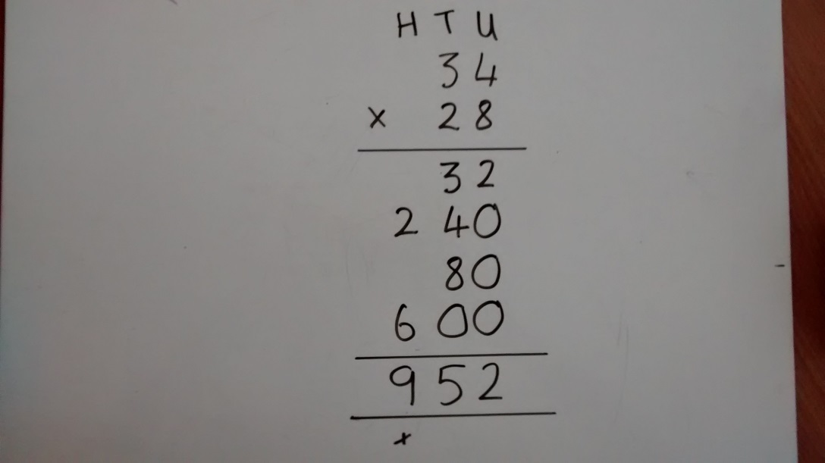

*Example problem – there are 34 biscuits in a pack. How many biscuits will there be in 28 packs?*

Number sentence 34 x 28 (34 packs of 28)

Inverse 952 ÷ 28 = 34 (952 biscuits make 28 packs of 34)

This method can now be applied to larger numbers and decimals.

|  |
| --- |
| Multiplication short column method |

When children are very confident and secure they can be introduced to the short method. This involves using their understanding of ‘carrying’ in addition.

Again they should start with multiplying by the units and then multiply by the tens.

*Example – How many eggs are there in 45 boxes of a dozen?*

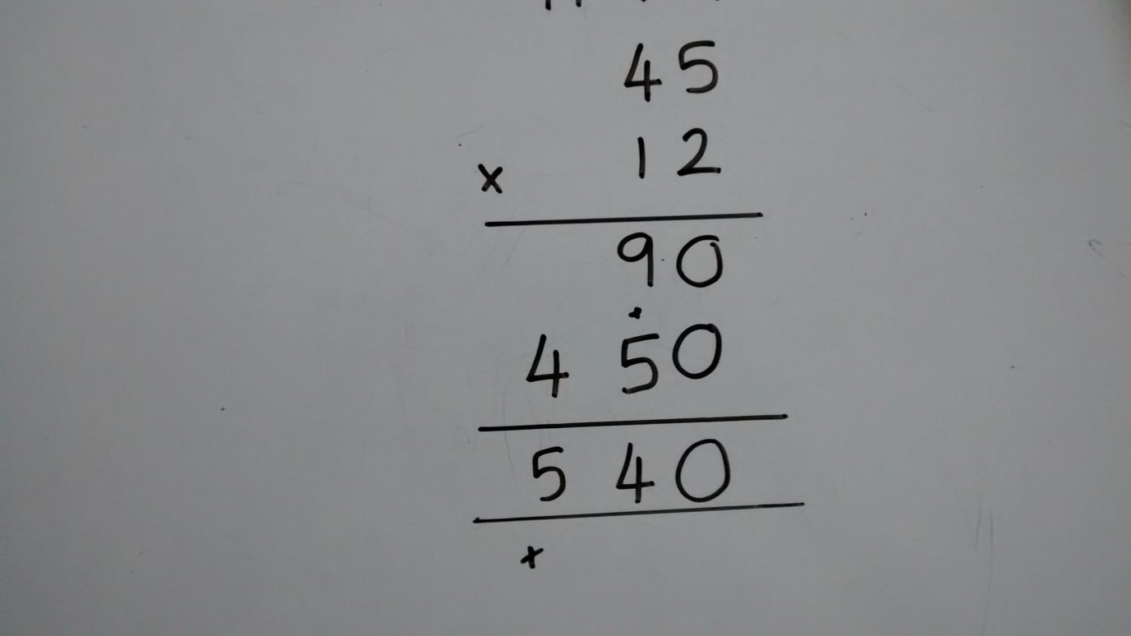

Number sentence 45 x 12 45 boxes of 12)

Inverse 540 ÷ 12 = 45 (540 eggs make 45 boxes of 12)

Remember to challenge children you do not need to always use increasingly large numbers. You can challenge their thinking and reasoning through the type of problems you choose to provide.

Whole school policy for the progression of division throughout the school

Our policy:

* Children should work through the following progression in line with National Curriculum expectations if appropriate.
* Appropriate and consistent vocabulary will be used throughout the school.
* Practical resources will support the learning of division throughout the school moving on to drawings and representations when secure.
* Mental multiplication strategies will be taught throughout the school to encourage fluency with times tables and application of these facts.
* Informal and then formal written methods will be used throughout the school for increasingly large numbers
* Children will learn about remainders throughout all stages of this progression.
* Children should be able to work out when division is needed to solve a problem and then whether a mental or written strategy is most effective
* Children should understand and use the relationship between division and multiplication through representations such as arrays.
* Children will also learn strategies to estimate and to check their answer is reasonable

|  |
| --- |
| Division by sharing using objects |

Children share out objects one at a time equally and use jottings to represent these objects.

*Example problem : If 6 apples are shared between 2 children, how many will they each have?*

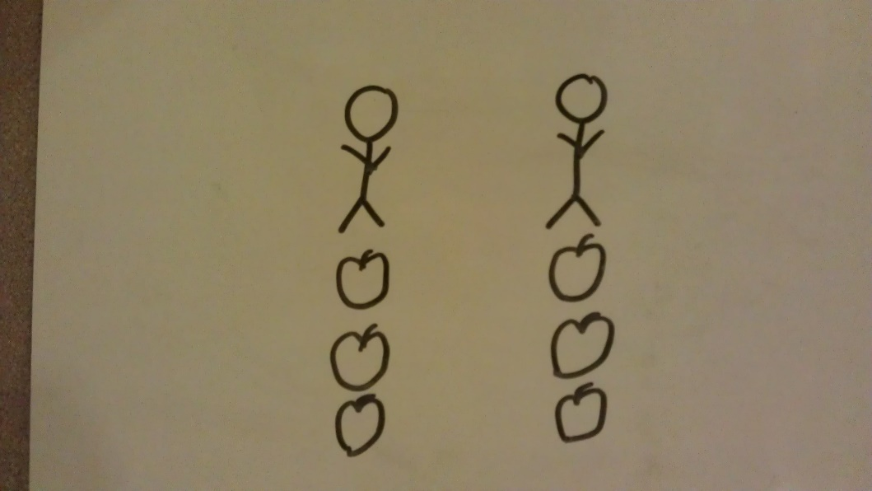

*Number sentence 6 ÷ 2 = 3 (6 apples are shared between 2 children)*

*Inverse 2 x 3 = 6 (the 2 children have 3 apples each)*

|  |
| --- |
| Division by grouping using objects |

Children start with all the objects and take away a group until all the objects are used up. The number of groups is then counted. Jotting can then be used to represent the groups.

*Example problem: Each box holds 3 apples. If I have 12 apples altogether, how many boxes can I fill?*

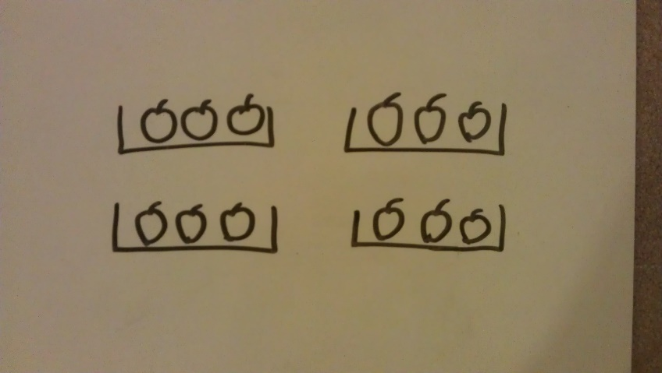

Number sentence 12 ÷ 3 = 4 (12 apples are split into groups of 3)

Inverse 4 x 3 = 12 (there are 4 boxes of 3 apples)

|  |
| --- |
| Division as repeated subtraction on a structured number line |

Children start with the whole amount and count back in groups until they have used up all the objects. The number of jumps **is** the number of groups they have made. (Children may wish to use real objects on the number line to start with.)

*Example problem: I can fit 5 apples in a box. If I have 30 apples how many boxes will I need?*

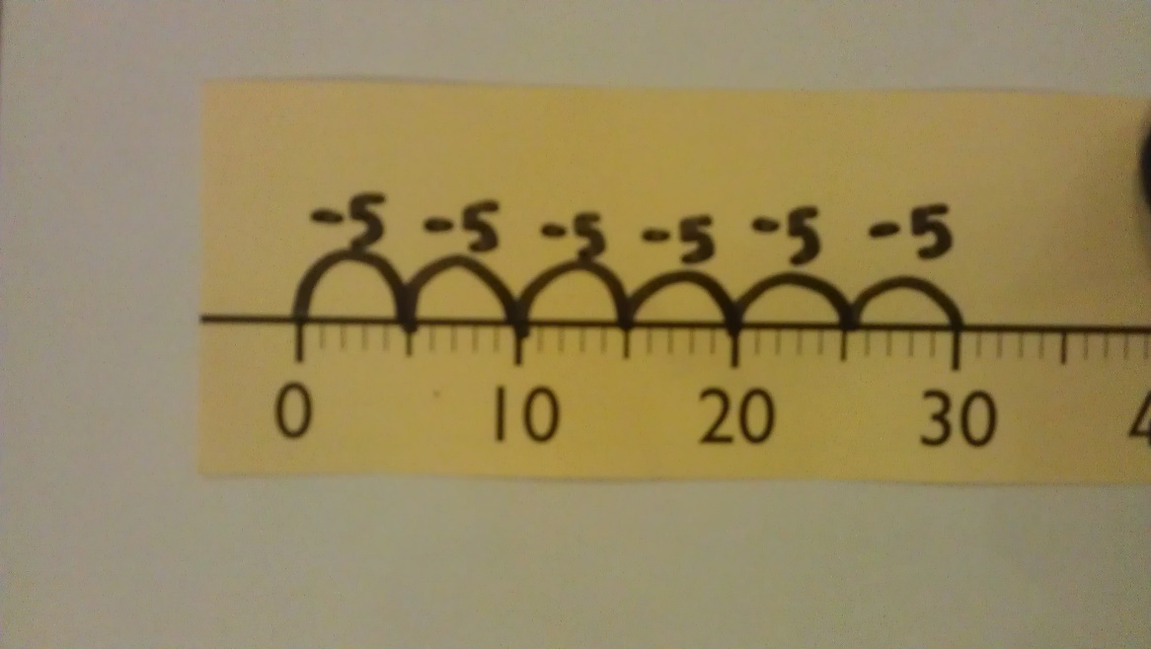

Number sentence 30 ÷ 5 = 6 (30 apples are grouped into boxes of 5)

Inverse 6 x 5 = 30 (There are 6 boxes of 5)

|  |
| --- |
| Division as repeated subtraction on an unstructured number line |

Children draw out their own number line. On the number line they write the numbers for when they start and where they land after each jump. They also write down what is being subtracted each time to keep track.

*Example problem: 25 cakes are packed into boxes. There are 4 cakes in each box. How many full boxes can be made?*

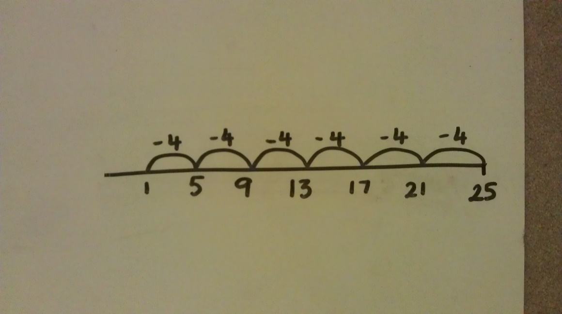

Number sentence 25 ÷ 4 = 6 remainder 1 (25 cakes are put into groups of 4.

Six boxes are filled and there is one cake left over)

Inverse 6 x 4 = 24 (There are 6 full boxes of 4 cakes)

|  |
| --- |
| Division using part-whole (cherry) model using times tables |

Children will use the part-whole model to partition number into chunks are easier to divide. To do this, children will need to be confident with their times tables. They will also need to be confident with multiples of 10.

*Example problem with NO remainder: Oranges are sold in packs of 3. If I had 39 oranges how many full packs would this be?*

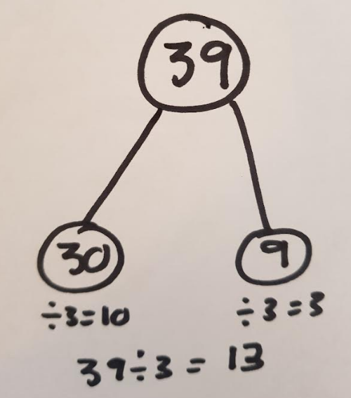

Number sentence 39 ÷ 3 = 13 (39 oranges are in packs of 3.

There are 13 full boxes.)

Inverse 13 x 3 = 39 (There are 13 full packs with 3 oranges)

*Example problem with a remainder: Oranges are sold in packs of 4. If I had 46 oranges how many full packs would this be?*

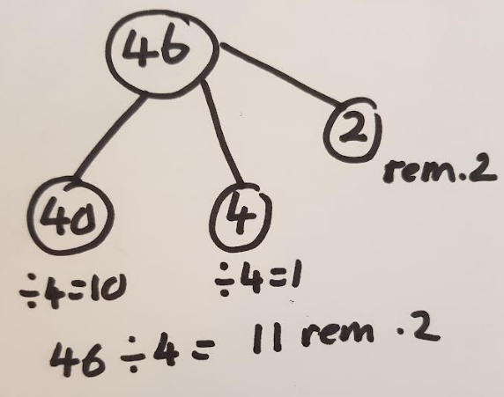

Number sentence 46 ÷ 4 = 11 rem 2 (46 oranges are put into packs of 6.

There are 11 full boxes and two left.)

Inverse 11 x 4 = 44 (There are 11 full boxes with 4 oranges)

|  |
| --- |
| Division using part-whole model with larger numbers |

Once the children are confident dividing with numbers in their times tables, they can then apply this to larger numbers. They will need to be confident with facts such as 30 x 4 = 120.

*Problem: 92 mugs are packaged in boxes of 4. How many boxes can be made?*

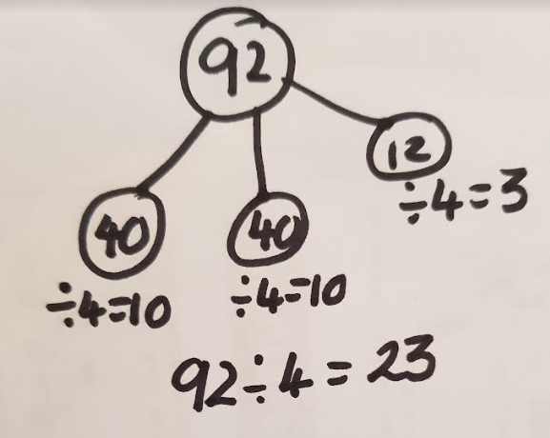

Number sentence 92 ÷ 4 = 23 (92 mugs are put into boxes of 4.

There are 23 full boxes)

Inverse 23 x 4 = 92 (There are 23 full boxes each with

4 mugs)

OR in larger chunks using multiples of 10

*Problem: 168 mugs are packaged in boxes of 4. How many boxes can be made?*

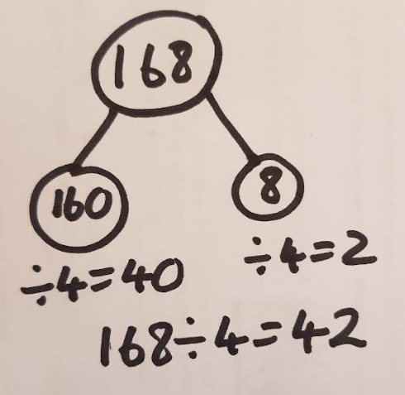

Number sentence 168 ÷ 4 = 42 (168 mugs are put into boxes of 4.

There are 42 full boxes)

Inverse 42 x 4 = 168 (There are 42 full boxes each with

4 mugs)

|  |
| --- |
| Short division |

When the children are completely confident with the vertical chunking method and can explain their understanding and methods then they can move on to the short method.

*Problem: A tailor has 235 buttons. If he needs 6 for each suit he makes, how many complete suits can he make?*

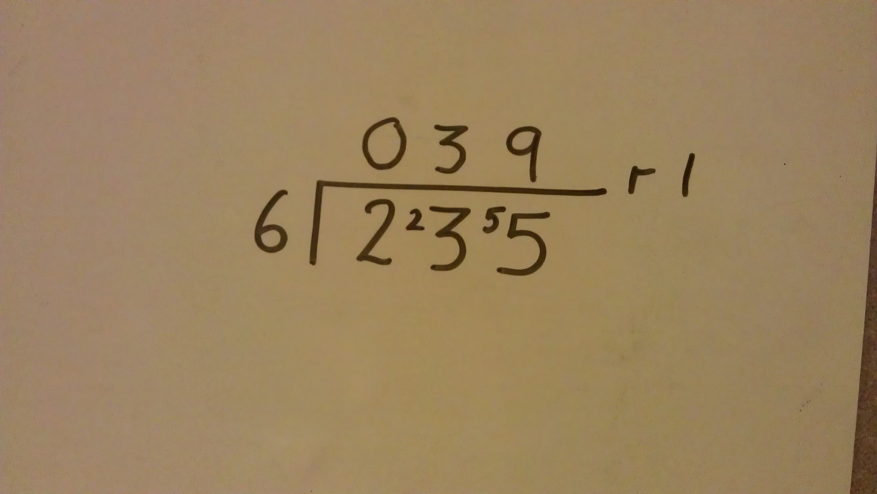

Children are using their knowledge from partitioning to help solve this.

* 30 x 6 = 180 so 3 goes in the tens column for the answer
* 230 – 180 = 50 so the remainder of 5 tens is carried into the units
* 9 x 6 = 54 and there is one remaining.

Number sentence 235 ÷ 6 = 39 r 1 (234 buttons are put into groups of 6.

There are 39 groups and 1 button left)

Inverse 39 x 6 = 234 (You can make 39 suits each with 6

Buttons)

|  |
| --- |
| Long division |

The long method of division should not be introduced until Year 6. It follows on from short division but is only really tested on Arithmetic paper. It is more important that children are very secure on short division.

These examples are taken from Statutory Curriculum guidance.

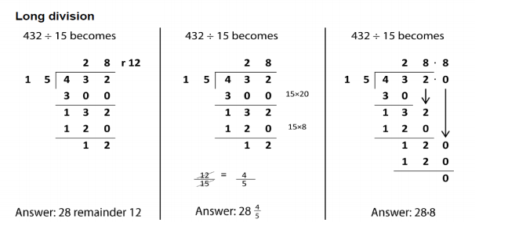

|  |
| --- |
| Division at this stage |

By now children should confident:

* Dividing a 4 digit number by a 1 or 2 digit number
* Expressing the remainder in a variety of ways depending on the context
  + Whole number
  + Rounding up or down
  + Fraction or decimal (e.g. money)