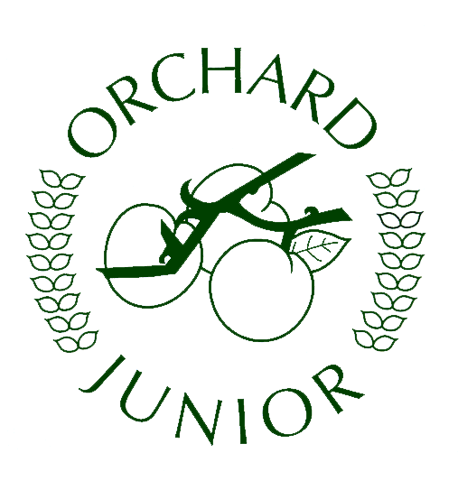
Year 4 Newsletter Spring 1
The Vikings are coming!
Raiders, Traders or Settlers?
Happy New Year! We hope you all had a wonderful break and are ready for yet another busy term! This half term, the children will be learning all about the Vikings. This term brings our 1st Dress up day (Tuesday 10th January) and we’d like the children to come dressed as a Viking so that they can fully get in to role with our Visitor from “Creative History.” Fortunately, we also have a Viking related trip to Noadswood on 16th January (No fancy Dress required on this day) where the children will continue their Viking learning .

Extended Learning Opportunities:
Did Vikings really have horns? Did the Vikings settle? What kind of boats did they use?
What extra research can the children do to be able to answer our Historical Topic question:
Raiders, Traders or Settlers?

Key Dates
Tues 10th Jan - Dress up day Mon 16th Trip to Noadswood Jan (lunchboxes needed)
Wednesday 1st Feb 2:45 - Parents invited in for story telling

In Literacy:
Our Guided reading work will be based around the book, ‘How to train your dragon.’ Part one of our 1st unit of work, is the retelling of Viking sagas. The child will look at a range of sagas and learn how to become a story teller and then using the Year 4 writing objectives, write it up and publish. Throughout the unit, they shall also look at using the skill of inference and deduction to write character descriptions and scene setting with the key year 4 skills such as appropriate openers, subordinating clauses and the revision of dialogue. Moving on, the children will then learn to write an informative piece of writing – a Non-chronological report informing the reader about certain aspect of Viking life. Our final style of writing for this half term will be poetry based around dragons and in the form of Kenning. The children will focus on language use, imagery and the impact on the reader.

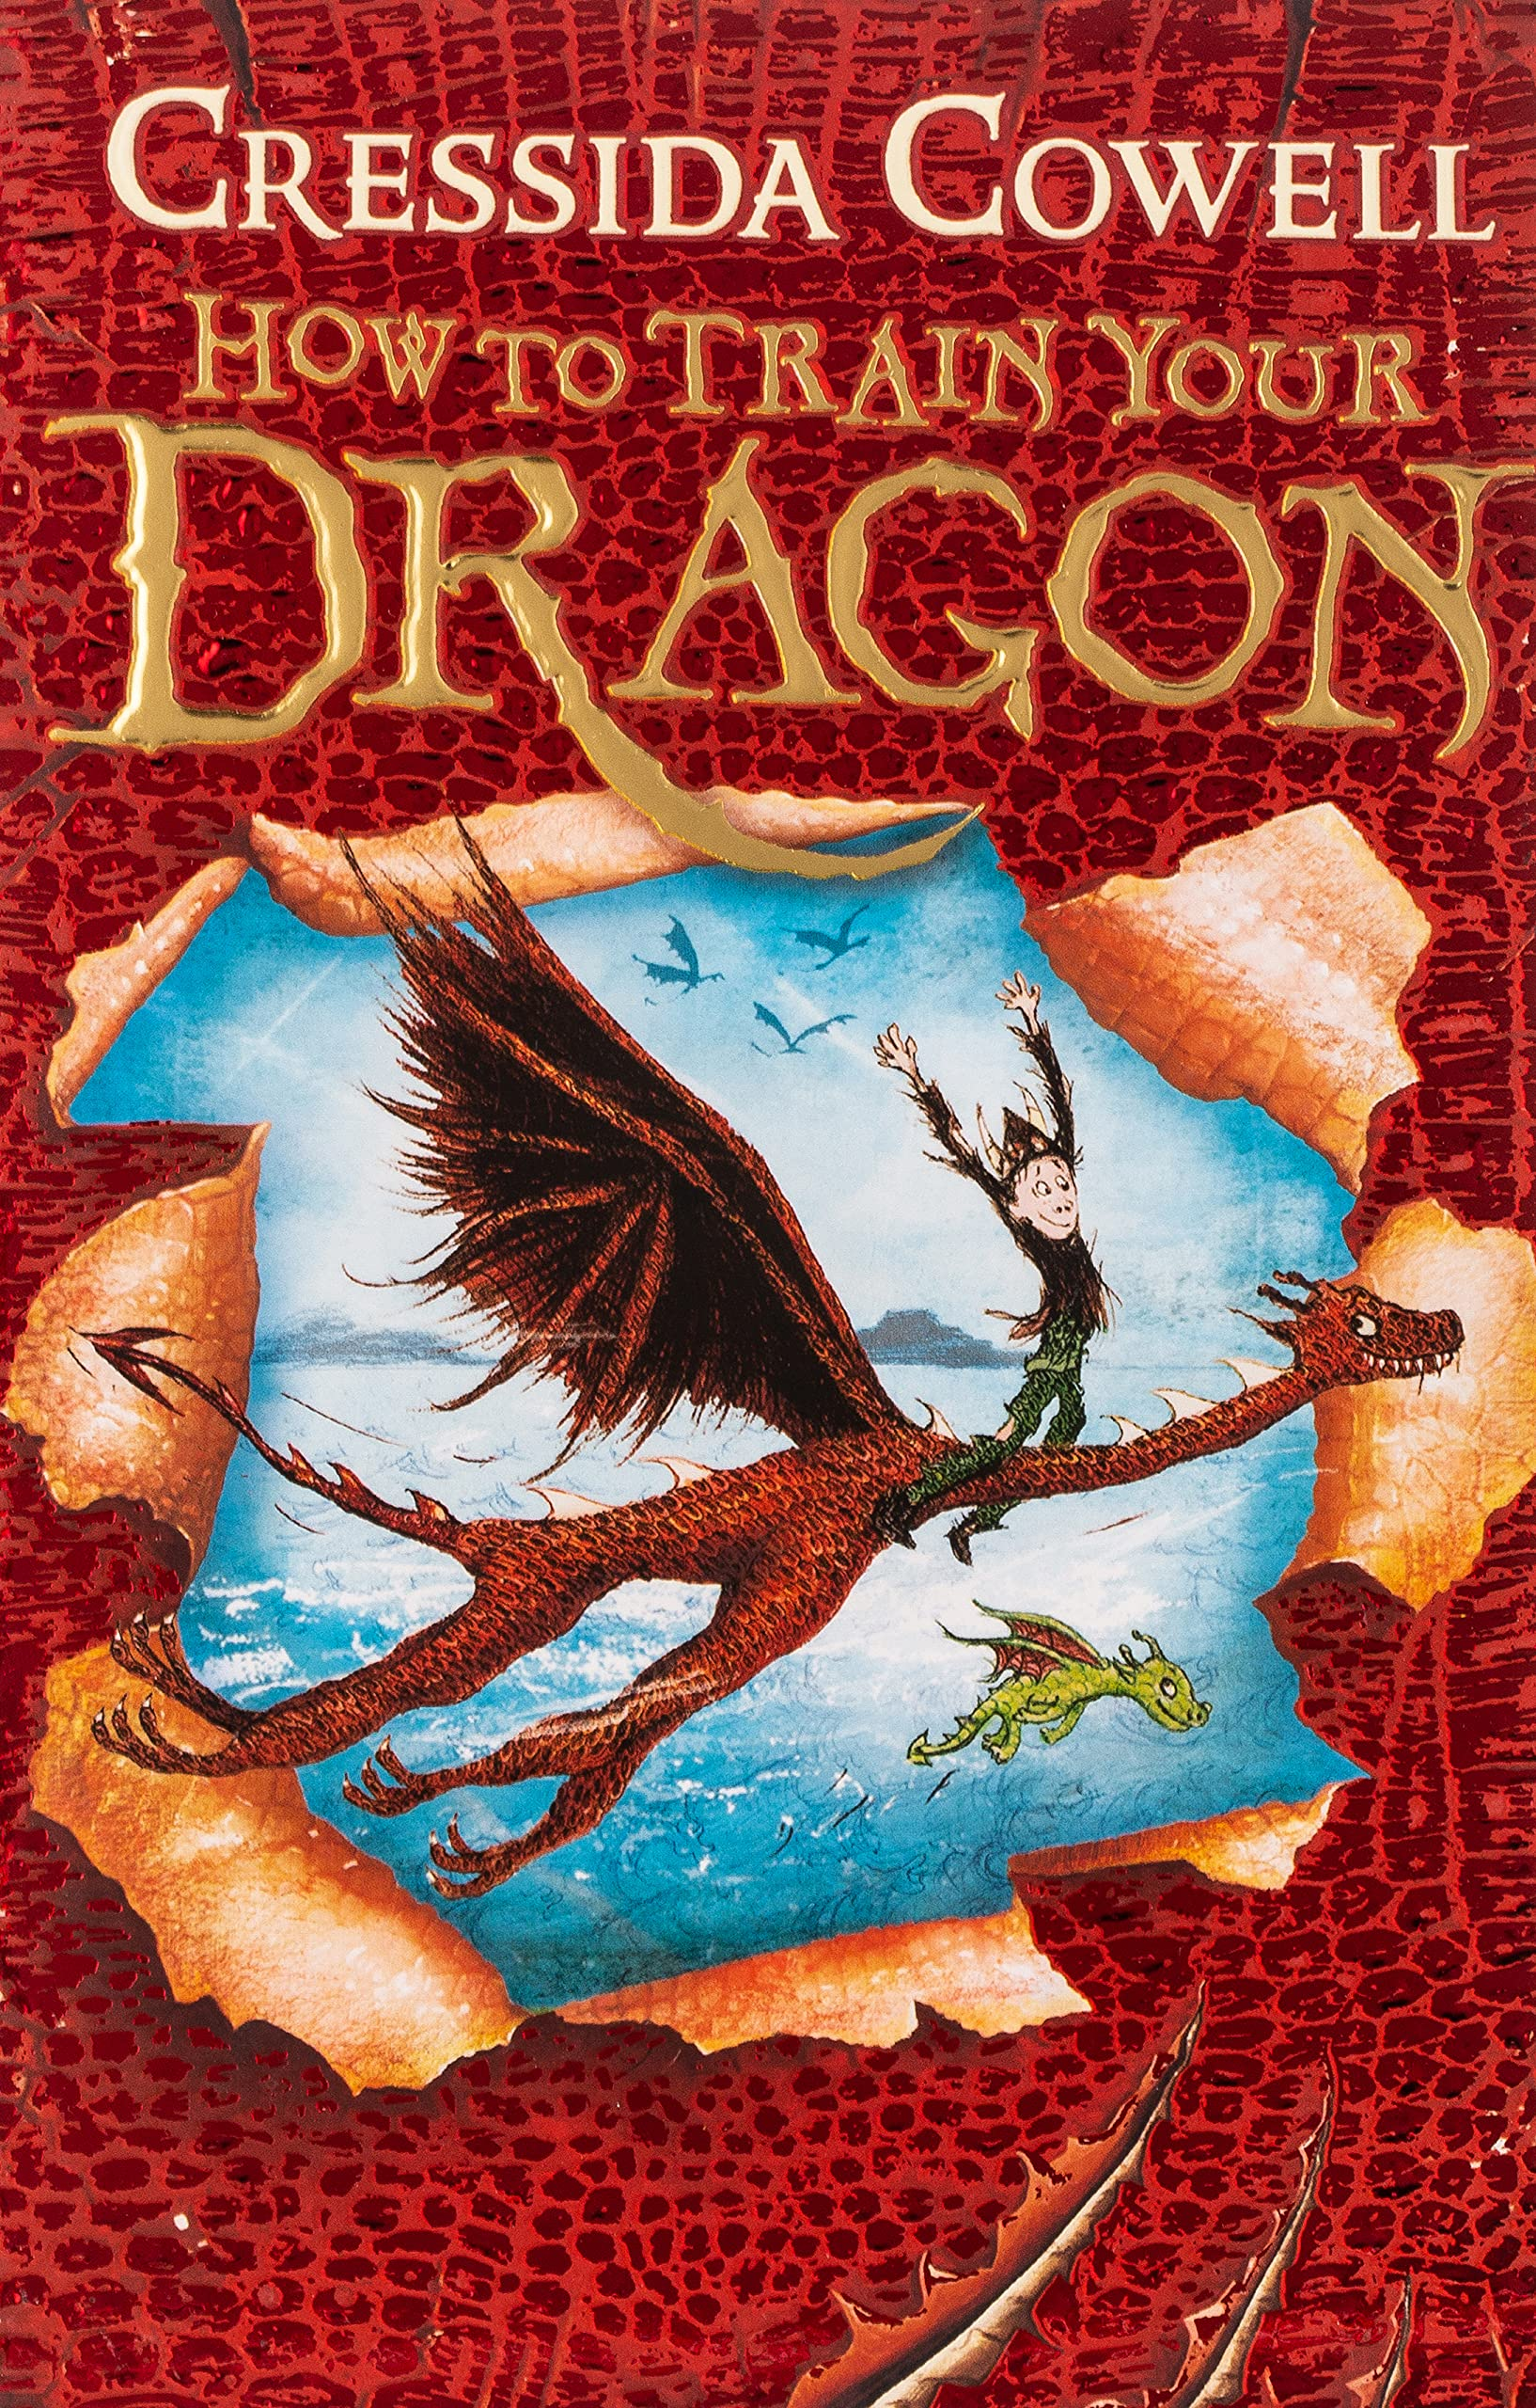

In Maths:
We will begin the term with a focus on division and then moving on to decimals and fractions.
Throughout the term, we will continue to build on our mental arithmetic skills and secure our formal recording skills for calculations for +-x.
To extend our learning, we will develop our mathematical reasoning to prove and explain what we understand.
The children have been brilliant at learning their times tables so far and it is really helping their everyday maths work. Please make sure your child continues to regularly practise their times tables. If you are stuck for ideas on how to practise these, please speak to your class teacher.

In History:
This term, the children will discover who the Vikings were, when in history they lived, where they came from and what made them decide to invade Britain. We begin with a hook day (Tuesday 10th January). This is a dress up day with a visitor where they will be looking at Viking artefacts and how they were used in everyday life. We are also excited to be able to visit Noadswood school (Monday 16th January) Themed on Vikings- re-enactor, a DT session and a Science session.

Leading Question
Raiders, Traders or Settlers?

In Art:
The children will create a Viking boat scene by experimenting with mood using colour and mixing watercolour to produce a wash and other creative effects. They will incorporate and adapt these to create 3D work, e.g. montage and then finally linking them to ICT.

In Music:
Mrs Beton will be introducing African percussion this term. Throughout the term, they will be creating at least two different sounds on the drums: bass (dun) and tone (tek). They will be maintaining a steady beat counting in 2,3 and 4 metres, copy and match rhythm patterns in 2,3 and 4 metre fitting them to the steady beat.

In Computing:
The children will be leaning to use the programme 2animate and produce a range of Stop start animation films, building up seamless transitions and motions.

In Science:
During this half term, the children will be focusing on electricity beginning with identifying common appliances that run on electricity, constructing a simple series electrical circuit ensuring they can identify and name its basic parts, including cells, wires, bulbs, switches and buzzers and moving on to identify whether or not a lamp will light in a simple series circuit. Then finally, being able to recognise the use of a switch within a circuit.

In French:
The focus for this half term is – je peux. The children will to state what they can and can’t do in French

In RE:
The children will be explain the meaning of the concept symbol and then being able to describe how and why the symbols of bread and wine are used by Christians. From this, they will be taught how to describe the importance of the symbols to Christians and themselves relating to their own lives.

In PSHE:
In this unit of work, we will be looking at belonging to community, focusing on: the meaning and the benefits of living in a community; to recognise that they belong to different communities as well as the school community; about the different groups that make up and contribute to a community; about the individuals and groups that help the local community, including through volunteering and work and how to show compassion towards others in need and the shared responsibilities of caring for them.

Reminders: Homework
* There are 3 expectations for homework each week – evidence of homework will be monitored:
READING – a minimum of 3 x a week and this should be signed off in their reading book which will be checked every Monday.
TIMES TABLES – the children will work through the different stages of the times table challenge and therefore MUST know the multiplication and division facts for each times table by the end of year 4. The children will be tested on a Wednesday.
SPELLINGS – The spelling book sent home is to be filled in and the weekly spellings will be stuck in every Friday. The weekly test is also on a FRIDAY, which will be completed in the back of this book too so you can keep an eye on progress. Please ask if you need a new book.
YEAR 4 – Stage 4 words | WEEK 1 | WEEK 2 | WEEK 3 | WEEK 4 | WEEK 5 | WEEK 6 | WEEK 7
 | suffix ‘-ous.’ | The ‘ee’ sound spelt with an ‘i.’ | suffix ‘-ous.’ | Challenge Words | The ‘au’ digraph. | suffix ‘-ion’ | e suffix ‘-ion’ becomes ’-ssion’
 | courageous  outrageous  nervous  famous  adventurous  disadvantageous  ridiculous  carnivorous  rapturous  torturous | merriment  happiness  plentiful  penniless  happily  prettiest  nastiness  beautiful  pitiful  silliness | serious  obvious  curious  hideous  spontaneous  courteous  furious  various  victorious  gaseous | breath  business  caught  different  exercise  extreme  medicine  possession  although  thought | naughty  caught  fraught  automatic  astronaut  cause  author  applaud  taught  audience | invention  injection  action  hesitation  completion  stagnation  nomination  migration  conservation  selection | expression  discussion  confession  permission  admission  impression  obsession  procession  omission  concussion

YEAR 4 – Stage 3 words – Mrs Kirwan | WEEK 1 | WEEK 2 | WEEK 3 | WEEK 4 | WEEK 5 | WEEK 6 | WEEK 7
 | The long /a/ vowel sound spelled ’ey | Adding the suffix –ly to an adjective turns it into an adverb. | Homophones | Challenge words | The /l/ sound spelled ‘-al’ at the end of words. | The /l/ sound spelled ‘-le’ at the end of words. | Adding the suffix ‘–ly’
 | obey  prey  convey  survey  grey  osprey  disobey  they  surveyor  conveyor | Calmly  exactly  deadly  bravely  boldly  gladly  deeply  clearly  hourly  quickly | grate  great  grown  groan  main  mane  meat  meet  missed  mist | build  describe  imagine  library  natural  ordinary  promise  recent  suppose  weight | arrival  burial  comical  emotional  national  magical  personal  optional  survival  tropical | battle  article  struggle  possible  capable  settle  humble  terrible  example  adjustable | gently  simply  humbly  nobly  durably  terribly  incredibly responsibly  wrinkly  possibly

YEAR 4 –Mrs Rutter Rutter’s group words | WEEK 1 | WEEK 2 | WEEK 3 | WEEK 4 | WEEK 5 | WEEK 6 | WEEK 7
 | come  push  said  have  was  some | buses  little  what  when  out  children | oh  ask  want  who  because  Mrs | your  very  whole  people  would  please | where  their  should  once  two  Mr | house  any  here  asked  mouse  many | sugar  could  water  again  friend  could

PE kits needed on Tuesday and Fridays for ALL.
Please ensure your child comes to school in the correct kit (plain white t-shirt, plain black shorts, school jumper and trainers), hair tied back and wearing correct footwear on these days.

If you have any queries or questions, please feel free to email your child’s class teacher:
4JD@orchardjunior.com 4MB@orchardjunior.com 4BS@orchardjunior.com
Here’s to another fun, exciting and wonderful half term!
Many thanks for your support. The Year 4 Team
Many thanks for your support. The Year 4 Team

