Pupil Premium Strategy Statement 2023 -2024
This statement details our school’s use of Pupil Premium funding to help improve the attainment and outcomes of our disadvantaged pupils.
It outlines our Pupil Premium strategy and how we intend to spend the funding this academic year.
School Overview

Detail | Data
School name | Orchard Junior School
Number of pupils in school | 357
Proportion (%) of Pupil Premium eligible pupils | 16.3% (58 pupils)
Academic year that our Pupil Premium Strategy plan covers | 2023-2024
Date this statement was published | October 2023
Date on which it will be reviewed | Dec 2023, March 2024, July 2024
Statement authorised by | Carol Taylor, Headteacher
Pupil Premium lead | Claire Goldup, Deputy Headteacher
Governor lead | Nikki Brigg

Funding Overview

Detail | Data
Pupil Premium funding allocation this academic year | £84,390

(National Tutoring Programme: £4320)

Part A: Pupil Premium Strategy Plan
Statement of intent
At Orchard Junior School, our intention is that all pupils, irrespective of their background or the challenges they face, make good progress and achieve high attainment across all subject areas. The focus of our Pupil Premium Strategy is to support disadvantaged pupils to achieve that goal, including progress for those that are already high attainers.

We will consider the challenges faced by vulnerable pupils, such as those who have a social worker or have been adopted. The activity we have outlined in this statement is also intended to support their needs, regardless of whether they are disadvantaged or not.

High-quality teaching is the heart of our approach, with a focus on areas in which disadvantaged pupils require the most support and targeted intervention. This is proven to have the greatest impact on closing the disadvantage attainment gap and at the same time will benefit the non-disadvantaged pupils at Orchard Junior School. Implicit in the intended outcomes detailed below, is the intention that non-disadvantaged pupils’ attainment will also be improved.

Our approach will be responsive to common challenges and individual needs, rooted in robust diagnostic assessment. To ensure this is effective we will:
- ensure disadvantaged pupils are challenged in the work they are set
- act early to intervene at the point need is identified
- adopt a whole school approach in which all staff take responsibility for disadvantaged pupils’ outcomes and raise expectations of what they can achieve
Our aim for all pupils is that their progress is consistent, sustained and comparable with their peers.

Challenges
This details the key challenges to achievement that we have identified among our disadvantaged pupils.
Challenge | Detail of challenge
1 | Vocabulary:  Assessments, observation and discussions with pupils indicate underdeveloped oral language skills and vocabulary gaps across the curriculum.
2 | Reading:  Assessments, observations and discussions with pupils indicate that where progress in reading is not consistent, sustained or comparable, there is a need to focus on fluency in order to improve pupils’ reading.
3 | Feedback for Learning:  Observations and discussions with teaching staff and pupils indicate that effective feedback for pupils has a significant impact on their learning and progress. This needs to be embedded consistently across the school to secure pupil engagement.
4 | Multiple presenting needs:  Assessments and observations show that disadvantaged pupils who present with other needs, including SEND, require additional support in order to access the learning in the classroom and make progress.
5 | Social and emotional well-being:  Observations and discussions with staff, pupils and their families have identified social and emotional issues for some pupils. These particularly affect the younger and disadvantaged pupils. The need for pastoral and additional support for social and emotional needs has increased significantly in recent years.
6 | Attendance:  Attendance data indicates that attendance among disadvantaged pupils is lower than for non-disadvantaged pupils and those pupils who are persistently absent are predominantly disadvantaged.
7 | Enrichment – cultural capital:  Observations and discussions with pupils highlight that not all pupils, particularly those who are disadvantaged, have many experiences beyond the local area. This is a limiting factor to building their cultural capital and is most significant for disadvantaged pupils.

Intended outcomes
This explains the outcomes we are aiming for and how we will measure whether they have been achieved.
Intended outcome | Success criteria
1. Vocabulary | - A whole school approach to teaching vocabulary in reading and across the curriculum will be embedded.  - All pupils will have access to vocabulary and text rich environments and a planned sequence of vocabulary development.  - Pupil voice will evidence impact of pre-teaching through an improved understanding and correct use of key vocabulary.  - Lesson observations and book looks will show that pupils are using subject specific vocabulary with understanding because adults consistently model vocabulary rich, spoken language.
2. Reading | - A whole school approach to teaching reading will be embedded, including a range of strategies for building and developing pupils’ fluency and reading for meaning.  - The progress of all pupils in reading will be consistent, sustained and comparable with their peers, considering their relative starting points.  - Pupils will be able to read decodable texts with fluency and understanding.
3. Feedback for Learning | - All pupils will be engaged in learning.  - A range of strategies will be used by teaching staff to assess pupils’ knowledge and understanding and engage them in learning.  - Assessments will inform planning for quality-first teaching and targeted interventions.
4. Multiple presenting needs | - Approaches to inclusive classroom practice will be embedded across the school so that all pupils can access the learning in the classroom.  - Disadvantaged pupils with additional needs will be supported through adaptation, intervention and scaffolds (e.g. assistive technology) to meet their individual needs to ensure equity of access to the curriculum.  - All pupils will achieve highly, particularly the most disadvantaged and pupils with SEND.
5. Social and emotional well-being | - Discussions with pupils, parents and staff will indicate that pupils’ decision-making skills, interaction with others and their self-management of emotions have improved.  - There will be less incidents recorded on CPOMs for all pupils, particularly those who have been identified as most disadvantaged.  - There will fewer incidents of disengagement and avoidance amongst those pupils who have previously displayed low resilience and poor self-image.  - Evidence in observations will show that all learners contribute in lessons, including those who had previously displayed low confidence.
6. Attendance | - Clear procedures in place to manage and improve the attendance of all pupils, particularly those at risk of persistent absence.  - The overall absence rate for all pupils will be no more than 4% and the attendance gap between disadvantaged pupils and non-disadvantaged pupils reduced to less than 2%.
7. Enrichment and development of cultural capital | - All children regardless of circumstance have the opportunity to take part in enrichment programs that broaden their cultural capital and experience.  These will include:  - Appreciation of the arts  - Outdoor and adventurous activities  - Educational experiences to enhance learning across the curriculum  - Activities and experiences that foster an enjoyment of reading  - External school improvement support will verify these findings in pupil’s day to day learning.

Activity in this academic year
This details how we intend to spend our pupil premium to address the challenges listed above.

Teaching (for example, CPD, recruitment and retention)
Budgeted cost: £ 44,000

Activity | Evidence that supports this approach | Challenge
 | Vocabulary Instruction  https://educationendowmentfoundation.org.uk/reading-house/vocabulary | 1
 | Reading Fluency  https://educationendowmentfoundation.org.uk/reading-house/fluency  Reading Comprehension Strategies  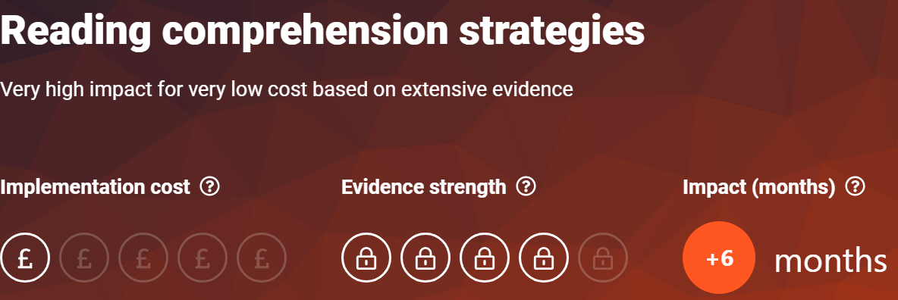  https://educationendowmentfoundation.org.uk/education-evidence/teaching-learning-toolkit/reading-comprehension-strategies | 2
 | Feedback for Learning  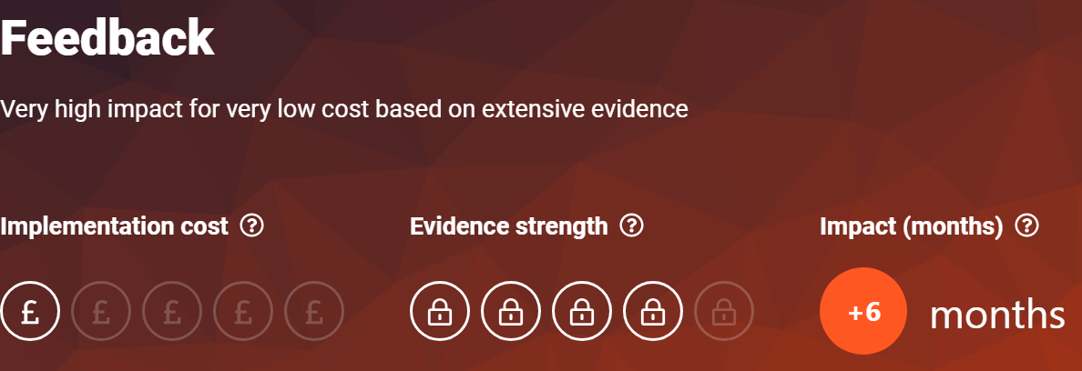  https://educationendowmentfoundation.org.uk/education-evidence/teaching-learning-toolkit/feedback  Teaching and Learning Coaching | 3
 | Inclusive Practice  https://educationendowmentfoundation.org.uk/education-evidence/guidance-reports/send  EP consultations for staff  Working Memory INSET | 4

Targeted academic support (tutoring, one-to-one support structured interventions)
Budgeted cost: £ 20,000
Activity | Evidence that supports this approach | Challenge number(s) addressed
Tutoring | https://educationendowmentfoundation.org.uk/support-for-schools/making-a-difference-with-effective-tutoring
Same-day teacher led interventions | https://educationendowmentfoundation.org.uk/education-evidence/guidance-reports/feedback

Wider strategies (for example, related to attendance, behaviour, wellbeing)
Budgeted cost: £20,000
Activity | Evidence that supports this approach | Challenge number(s) addressed
 | Social and emotional well-being  PACE:  https://www.oxfordshire.gov.uk/sites/default/files/file/children-and-families/PACEforteachers.pdf  PBS Training:  https://pbs.hants.gov.uk/home  ELSA:  https://www.elsanetwork.org/elsa-network/  Pastoral Lead  In-school TACs and TAFs | 5
 | Responsive and targeted approaches to attendance  Findings and implications:  • The average impact of responsive and targeted approaches to attendance is positive.  • There are a small number of studies and very few studies with low risk of bias.  • Common characteristics of these approaches include staff monitoring of pupil absences,  the identification of the causes of absences and then responsive, individualised  interventions that tackle those causes.  https://d2tic4wvo1iusb.cloudfront.net/production/documents/pages/Attendance-REA-report.pdf?v=1696834025  DfE Guidance:  https://assets.publishing.service.gov.uk/government/uploads/system/uploads/attachment_data/file/1099677/Working_together_to_improve_school_attendance.pdf  Improved communication with parents:  https://www.gov.uk/government/publications/working-together-to-improve-school-attendance/toolkit-for-schools-communicating-with-families-to-support-attendance | 6
Enrichment | Enrichment:  https://www.suttontrust.com/wp-content/uploads/2019/12/Subject-to-background1-1.pdf | 7

